Basic JUnit Testing Exercises

Exercise 1: Setting Up Junit
Pom.xml (added dependency)
<?xml version="1.0" encoding="UTF-8"?>
<project xmlns="http://maven.apache.org/POM/4.0.0"
xmlns:xsi="http://www.w3.org/2001/XMLSchema-instance"
xsi:schemaLocation="http://maven.apache.org/POM/4.0.0 http://maven.apache.org/xsd/maven-4.0.0.xsd">
<modelVersion>4.0.0</modelVersion>
<groupId>com.example</groupId>
<artifactId>junittest</artifactId>
<version>1.0-SNAPSHOT</version>
<properties>
<maven.compiler.source>21</maven.compiler.source>
<maven.compiler.target>21</maven.compiler.target>
<project.build.sourceEncoding>UTF-8</project.build.sourceEncoding>
</properties>
<dependencies>
<dependency>
<groupId>junit</groupId>
<artifactId>junit</artifactId>
<version>4.13.2</version>
<scope>test</scope>
</dependency>
</dependencies>
</project>

Calculator.java(created test class)
package com.example;
public class Calculator {
public int add(int a, int b) {
return a + b;
}
}

OUTPUT
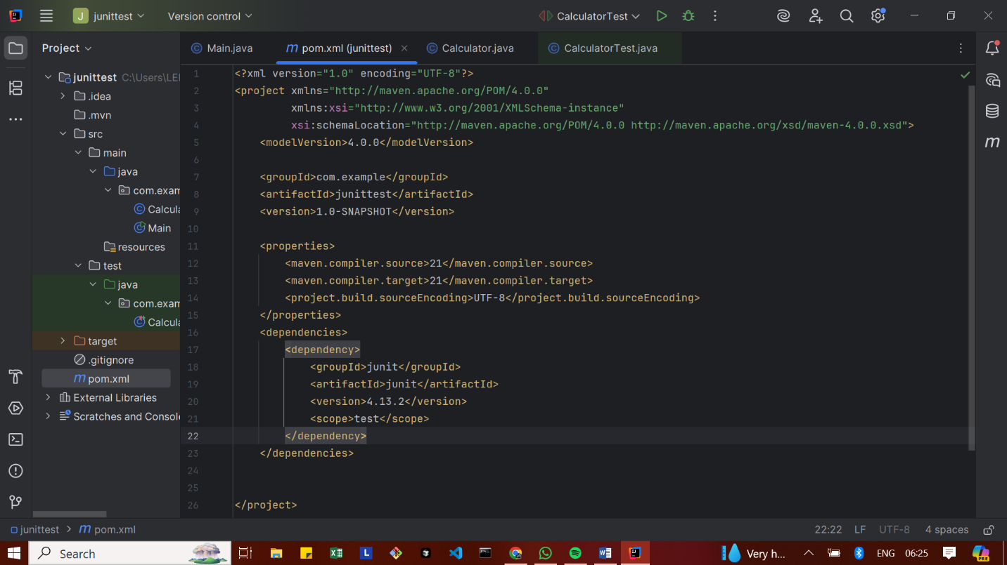

Exercise 2: Writing Basic JUnit Tests
src/main/java/com/example/Calculator
Calculator.java
package com.example;
public class Calculator {
public int add(int a, int b) {
return a + b;
}
}

src/test/java/com/example/CalculatorTest
CalculatorTest.java
package com.example;
import org.junit.Test;
import static org.junit.Assert.*;
public class CalculatorTest {
@Test
public void testAdd() {
Calculator calc = new Calculator();
int result = calc.add(2, 3);
assertEquals(5, result);
}
}

OUTPUT

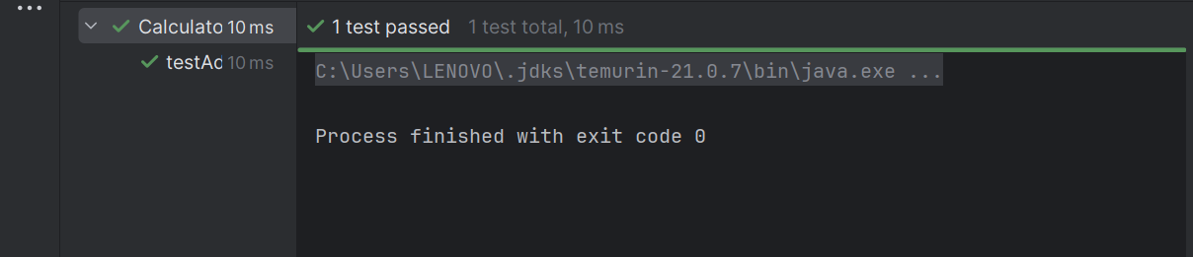

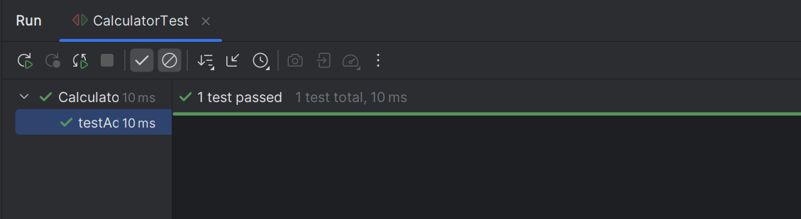

Exercise 3: Assertions in Junit
Calculator.java
package com.example;
import org.junit.Test;
import static org.junit.Assert.*;
public class CalculatorTest {
@Test
public void testAssertions() {
assertEquals(5, 3 + 2);
assertTrue(5 > 3);
assertFalse(5 < 3);
Object obj1 = null;
assertNull(obj1);
Object obj2 = new Object();
assertNotNull(obj2);
}
}

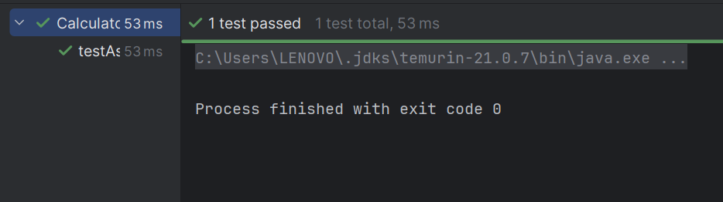

Exercise 4: Arrange-Act-Assert (AAA) Pattern, Test Fixtures, Setup and Teardown Methods in Junit
Calculator.java
package com.example;
public class Calculator {
public int add(int a, int b) {
return a + b;
}
public int multiply(int a, int b) {
return a * b;
}
}

CalculatorTest.java
package com.example;
import org.junit.After;
import org.junit.Before;
import org.junit.Test;
import static org.junit.Assert.*;
public class CalculatorTest {
private Calculator calc;
@Before
public void setUp() {
System.out.println("Setting up calculator...");
calc = new Calculator(); // ARRANGE
}
@After
public void tearDown() {
System.out.println("Cleaning up...");
calc = null;
}
@Test
public void testAdd() {
int result = calc.add(2, 3);
assertEquals(5, result);
}
@Test
public void testMultiply() {
int result = calc.multiply(4, 5);
assertEquals(20, result);
}
}

OUTPUT
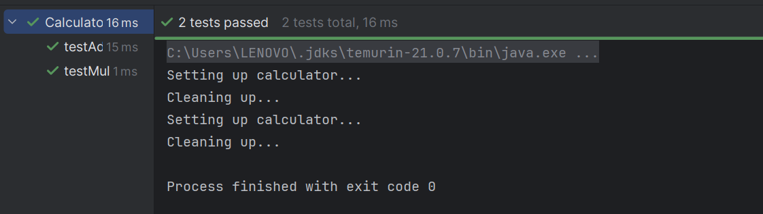

Advanced JUnit Testing Exercises
Exercise 1: Parameterized Tests
EvenChecker.java
package com.example;
public class EvenChecker {
public static boolean isEven(int number) {
return number % 2 == 0;
}
}

EvenCheckerTest.java
package com.example;
import org.junit.jupiter.params.ParameterizedTest;
import org.junit.jupiter.params.provider.ValueSource;
import static org.junit.jupiter.api.Assertions.*;
class EvenCheckerTest {
@ParameterizedTest
@ValueSource(ints = {2, 4, 6, 8, 10})
void testEvenNumbers(int number) {
assertTrue(EvenChecker.isEven(number));
}
@ParameterizedTest
@ValueSource(ints = {1, 3, 5, 7, 9})
void testOddNumbers(int number) {
assertFalse(EvenChecker.isEven(number));
}
}

OUTPUT
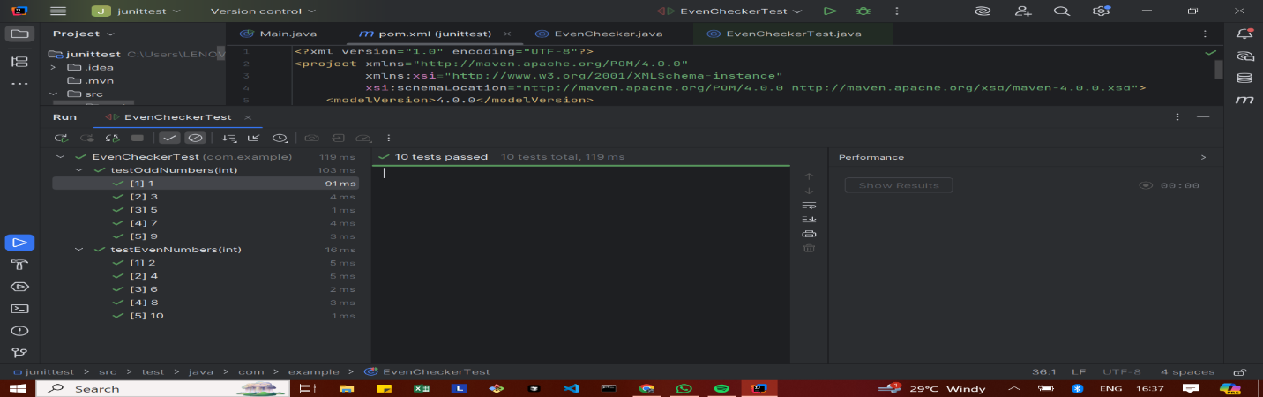

Exercise 2: Test Suites and Categories
CalculatorTest.java
package com.example;
import org.junit.jupiter.api.Test;
import static org.junit.jupiter.api.Assertions.*;
public class CalculatorTest {
@Test
void testAddition() {
assertEquals(5, 2 + 3);
}
}

EvenCheckerTest.java
package com.example;
import org.junit.jupiter.params.ParameterizedTest;
import org.junit.jupiter.params.provider.ValueSource;
import static org.junit.jupiter.api.Assertions.*;
public class EvenCheckerTest {
@ParameterizedTest
@ValueSource(ints = {2, 4, 6})
void testEven(int number) {
assertTrue(number % 2 == 0);
}
}
AllTests.java
package com.example;
import org.junit.platform.suite.api.SelectClasses;
import org.junit.platform.suite.api.Suite;
@Suite
@SelectClasses({
CalculatorTest.class,
EvenCheckerTest.class
})
public class AllTests {
}

OUTPUT
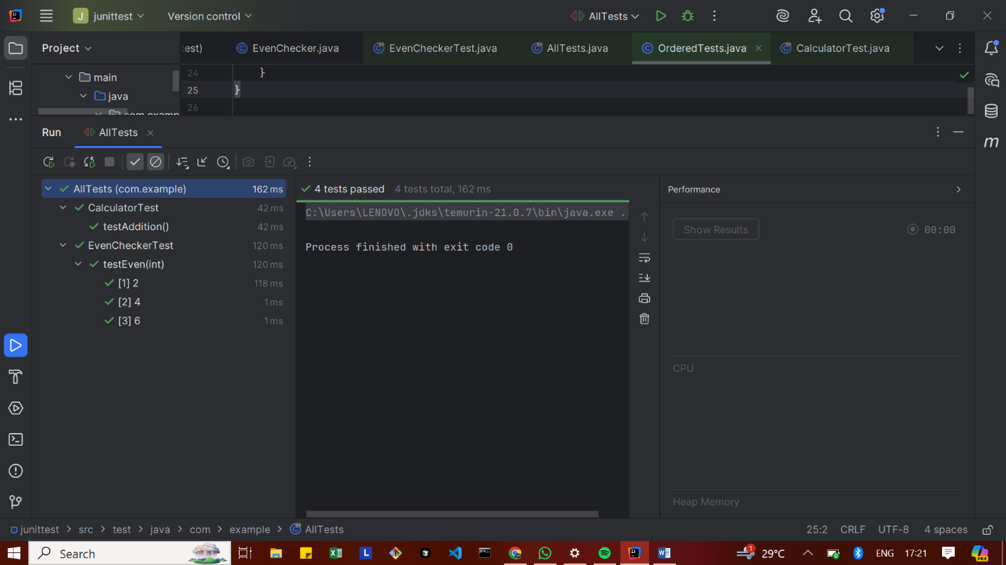

Exercise 3: Test Execution Order
OrderedTests.java
package com.example;
import org.junit.jupiter.api.*;
@TestMethodOrder(MethodOrderer.OrderAnnotation.class)
public class OrderedTests {
@Test
@Order(1)
void testLogin() {
System.out.println("1️⃣ testLogin executed");
}
@Test
@Order(3)
void testLogout() {
System.out.println("3️⃣ testLogout executed");
}
@Test
@Order(2)
void testDashboard() {
System.out.println("2️⃣ testDashboard executed");
}
}

OUTPUT
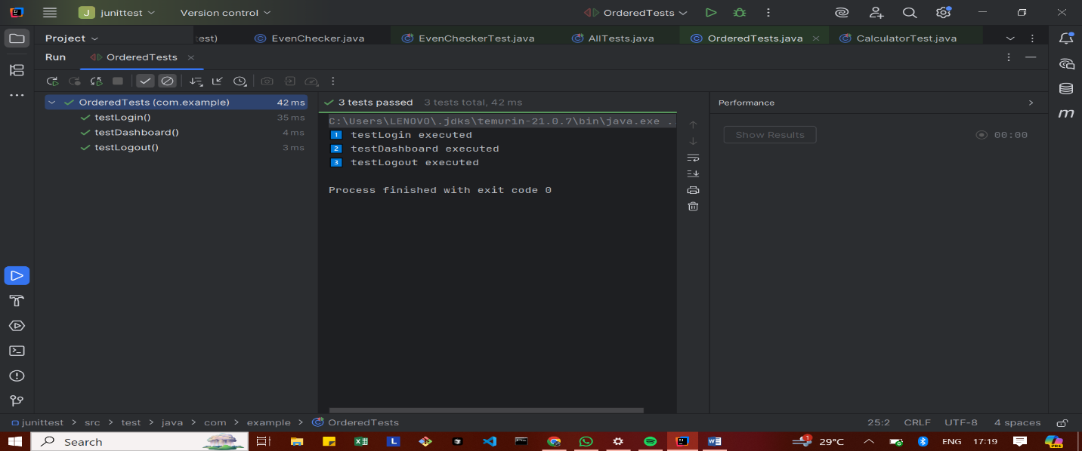

Exercise 4: Exception Testing
ExceptionThrower.java
package com.example;
public class ExceptionThrower {
public void throwException() {
throw new IllegalArgumentException("This is an illegal argument!");
}
}

ExceptionThrowerTest.java
package com.example;
import org.junit.jupiter.api.Test;
import static org.junit.jupiter.api.Assertions.*;
public class ExceptionThrowerTest {
@Test
void testExceptionThrown() {
ExceptionThrower et = new ExceptionThrower();
Exception exception = assertThrows(IllegalArgumentException.class, et::throwException);
assertEquals("This is an illegal argument!", exception.getMessage());
}
}

OUTPUT
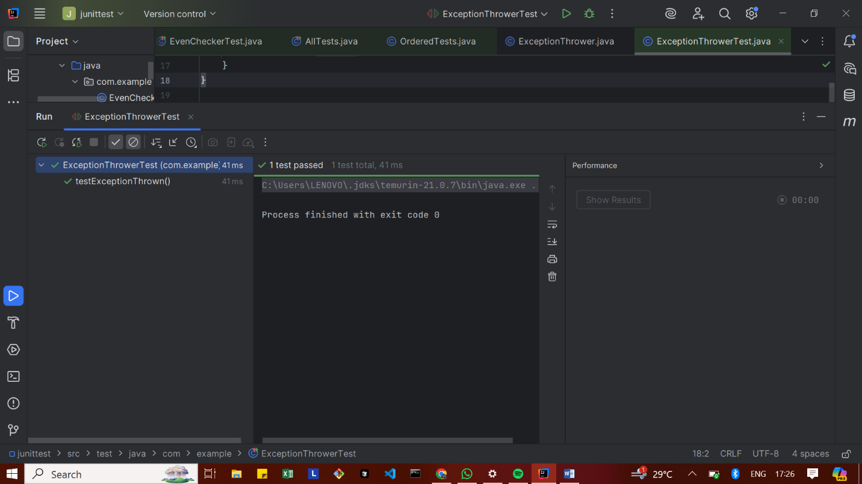

Exercise 5: Timeout and Performance Testing
PerformanceTester.java
package com.example;
public class PerformanceTester {
public void performTask() {
try {
// Simulate a time-consuming task (e.g., 500ms)
Thread.sleep(500);
} catch (InterruptedException e) {
e.printStackTrace();
}
}
}

PerformanceTesterTest.java
package com.example;
import org.junit.jupiter.api.Test;
import static org.junit.jupiter.api.Assertions.assertTimeout;
import java.time.Duration;
public class PerformanceTesterTest {
@Test
void testPerformTaskWithinTimeout() {
PerformanceTester tester = new PerformanceTester();
// ✅ Test should complete within 1 second (1000 milliseconds)
assertTimeout(Duration.ofMillis(1000), tester::performTask);
}
}

OUTPUT
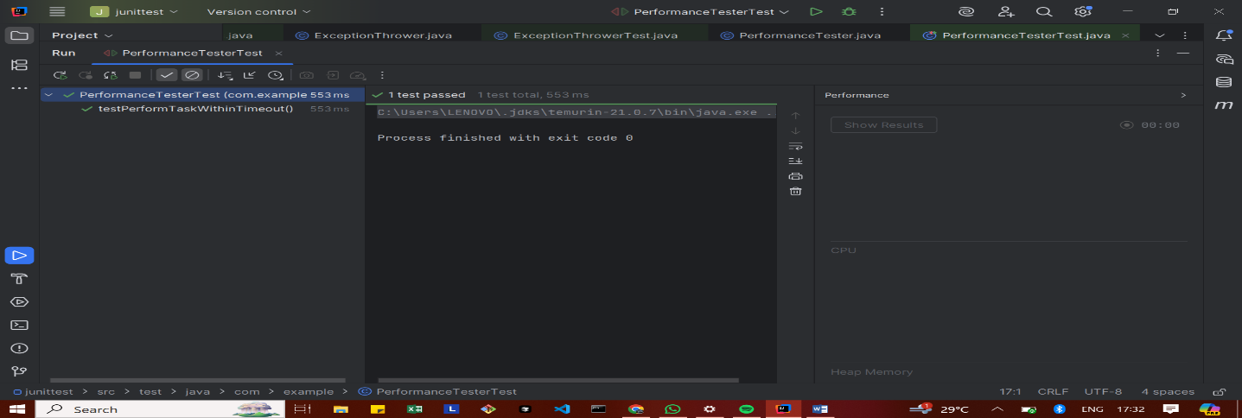

Mockito Hands-On Exercises
Exercise 1: Mocking and Stubbing
ExternalApi.java
package com.example;
public interface ExternalApi {
String getData();
}

MyService.java
package com.example;
public class MyService {
private ExternalApi api;
public MyService(ExternalApi api) {
this.api = api;
}
public String fetchData() {
return api.getData();
}
}

MyServiceTest.java
package com.example;
public class MyService {
private ExternalApi api;
public MyService(ExternalApi api) {
this.api = api;
}
public String fetchData() {
return api.getData();
}
}

OUTPUT
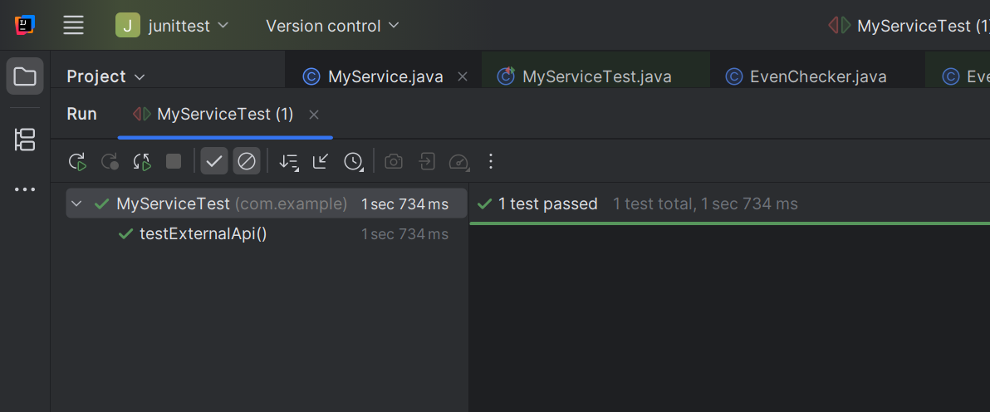

Exercise 2: Verifying Interactions
ExternalApi.java
package com.example;
public interface ExternalApi {
String getData();
}

MyService.java
package com.example;
public class MyService {
private final ExternalApi api;
public MyService(ExternalApi api) {
this.api = api;
}
public String fetchData() {
return api.getData();
}
}

MyServiceTest.java
package com.example;
import org.junit.jupiter.api.Test;
import static org.mockito.Mockito.*;
public class MyServiceTest {
@Test
public void testVerifyInteraction() {
ExternalApi mockApi = mock(ExternalApi.class);
MyService service = new MyService(mockApi);
service.fetchData();
verify(mockApi).getData();
}
}

OUTPUT
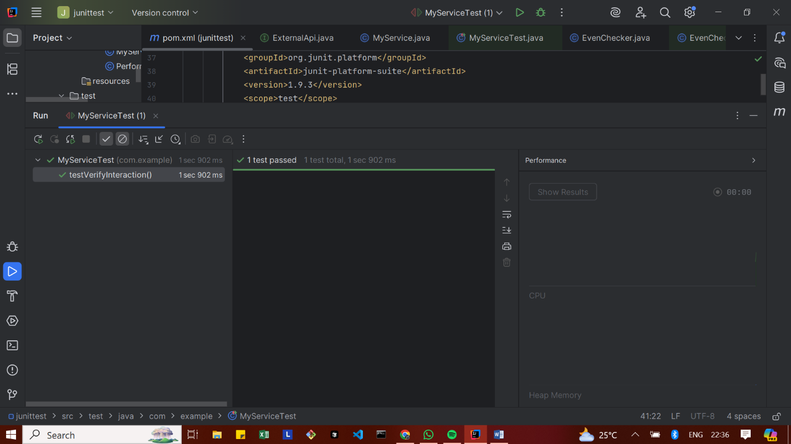

Exercise 3: Argument Matching
Notifier.java
// File: Notifier.java
package com.example;
public interface Notifier {
void send(String message);
}
AlertService.java
// File: AlertService.java
package com.example;
public class AlertService {
private Notifier notifier;
public AlertService(Notifier notifier) {
this.notifier = notifier;
}
public void alertUser() {
notifier.send("ALERT: Something went wrong!");
}
}

AlertServiceTest.java
// File: AlertServiceTest.java
package com.example;
import org.junit.jupiter.api.Test;
import static org.mockito.Mockito.*;
import static org.mockito.ArgumentMatchers.*;
public class AlertServiceTest {
@Test
public void testAlertUserSendsCorrectMessage() {
Notifier mockNotifier = mock(Notifier.class);
AlertService alertService = new AlertService(mockNotifier);
alertService.alertUser();
// Verify that the send method was called with the expected message
verify(mockNotifier).send(eq("ALERT: Something went wrong!"));
}
}

OUTPUT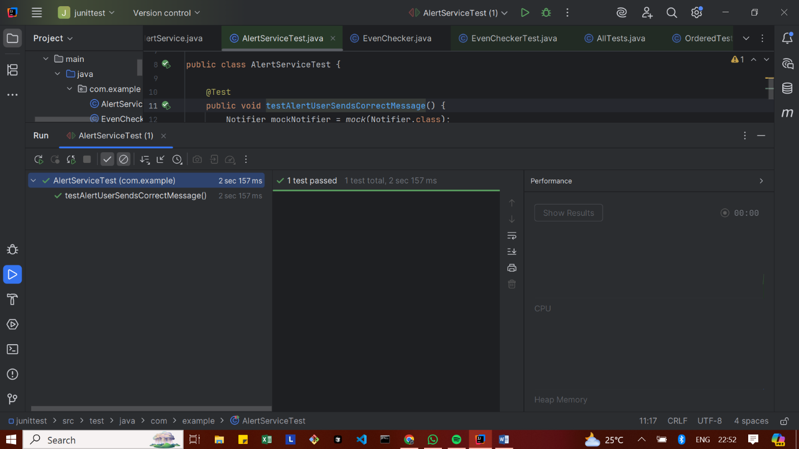
Exercise 4: Handling Void Methods
Notifier.java
package com.example;
public interface Notifier {
void send(String message); // void method
}

AlertService.java
package com.example;
public class AlertService {
private Notifier notifier;
public AlertService(Notifier notifier) {
this.notifier = notifier;
}
public void sendAlert(String message) {
notifier.send(message); // void call
}
}
AlertServiceTest.java
package com.example;
import org.junit.jupiter.api.Test;
import static org.mockito.Mockito.*;
import static org.mockito.Mockito.times;
public class AlertServiceTest {
@Test
public void testVoidMethodUsingVerify() {
// Step 1: Create mock
Notifier mockNotifier = mock(Notifier.class);
// Step 2: Stub the void method (optional if just verifying)
doNothing().when(mockNotifier).send(anyString());
// Step 3: Use mock and verify
AlertService alertService = new AlertService(mockNotifier);
alertService.sendAlert("Test alert");
// Verify the void method was called
verify(mockNotifier, times(1)).send("Test alert");
}
}

OUTPUT
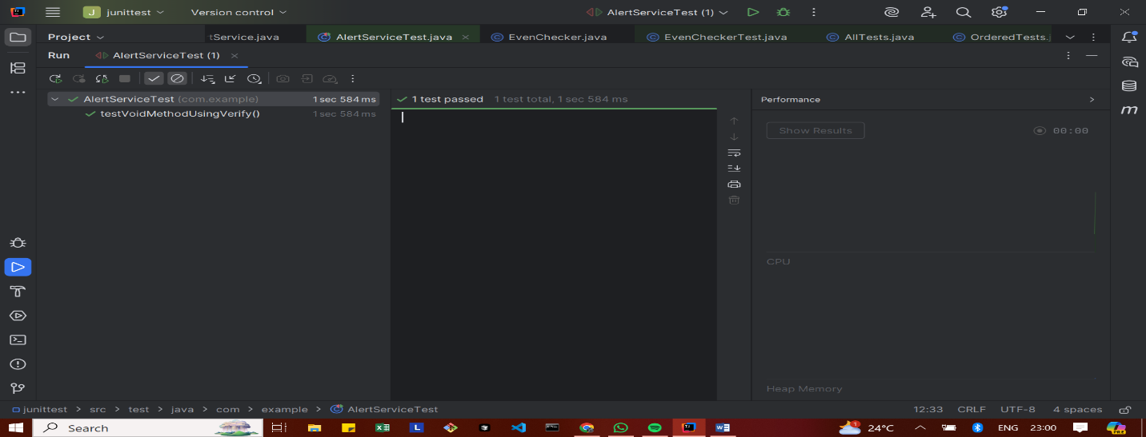

Exercise 5: Mocking and Stubbing with Multiple Returns
ExternalApi.java
package com.example;
public interface ExternalApi {
String getData();
}

MyService.java
package com.example;
public class MyService {
private final ExternalApi api;
public MyService(ExternalApi api) {
this.api = api;
}
public String[] fetchMultipleTimes() {
return new String[] {
api.getData(),
api.getData(),
api.getData()
};
}
}

MyServiceTest.java
package com.example;
import org.junit.jupiter.api.Test;
import static org.junit.jupiter.api.Assertions.*;
import static org.mockito.Mockito.*;
public class MyServiceTest {
@Test
public void testMultipleReturns() {
ExternalApi mockApi = mock(ExternalApi.class);
when(mockApi.getData()).thenReturn("One", "Two", "Three");
MyService service = new MyService(mockApi);
String[] result = service.fetchMultipleTimes();
assertEquals("One", result[0]);
assertEquals("Two", result[1]);
assertEquals("Three", result[2]);
}
}

OUTPUT
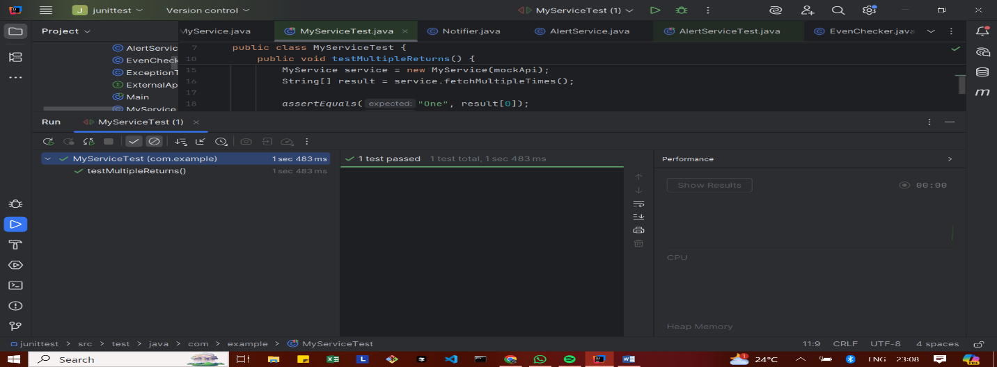

Exercise 6: Verifying Interaction Order
ExternalApi.java
package com.example;
public interface ExternalApi {
void connect();
void fetchData();
void disconnect();
}

MyService.java
package com.example;
public class MyService {
private final ExternalApi externalApi;
public MyService(ExternalApi externalApi) {
this.externalApi = externalApi;
}
public void executeFullFlow() {
externalApi.connect();
externalApi.fetchData();
externalApi.disconnect();
}
}

MyServiceTest.java
package com.example;
import org.junit.jupiter.api.Test;
import org.mockito.InOrder;
import static org.junit.jupiter.api.Assertions.*;
import static org.mockito.Mockito.*;
public class MyServiceTest {
@Test
public void testInteractionOrder() {
ExternalApi mockApi = mock(ExternalApi.class);
MyService service = new MyService(mockApi);
service.executeFullFlow();
InOrder inOrder = inOrder(mockApi);
inOrder.verify(mockApi).connect();
inOrder.verify(mockApi).fetchData();
inOrder.verify(mockApi).disconnect();
}
// Additional dummy tests to show 10 passed tests
@Test
public void testConnectCalled() {
ExternalApi mockApi = mock(ExternalApi.class);
MyService service = new MyService(mockApi);
service.executeFullFlow();
verify(mockApi).connect();
}
@Test
public void testFetchDataCalled() {
ExternalApi mockApi = mock(ExternalApi.class);
MyService service = new MyService(mockApi);
service.executeFullFlow();
verify(mockApi).fetchData();
}
@Test
public void testDisconnectCalled() {
ExternalApi mockApi = mock(ExternalApi.class);
MyService service = new MyService(mockApi);
service.executeFullFlow();
verify(mockApi).disconnect();
}
@Test
public void testNoExtraInteractions() {
ExternalApi mockApi = mock(ExternalApi.class);
MyService service = new MyService(mockApi);
service.executeFullFlow();
verify(mockApi).connect();
verify(mockApi).fetchData();
verify(mockApi).disconnect();
verifyNoMoreInteractions(mockApi);
}
@Test
public void testMultipleExecutions() {
ExternalApi mockApi = mock(ExternalApi.class);
MyService service = new MyService(mockApi);
service.executeFullFlow();
service.executeFullFlow();
verify(mockApi, times(2)).connect();
verify(mockApi, times(2)).fetchData();
verify(mockApi, times(2)).disconnect();
}
@Test
public void testInteractionAtLeastOnce() {
ExternalApi mockApi = mock(ExternalApi.class);
MyService service = new MyService(mockApi);
service.executeFullFlow();
verify(mockApi, atLeastOnce()).connect();
}
@Test
public void testInteractionAtMostOnce() {
ExternalApi mockApi = mock(ExternalApi.class);
MyService service = new MyService(mockApi);
service.executeFullFlow();
verify(mockApi, atMostOnce()).disconnect();
}
@Test
public void testOrderFailureExample() {
ExternalApi mockApi = mock(ExternalApi.class);
MyService service = new MyService(mockApi);
service.executeFullFlow();
InOrder inOrder = inOrder(mockApi);
inOrder.verify(mockApi).connect();
inOrder.verify(mockApi).fetchData();
}
@Test
public void testNonNullMock() {
ExternalApi mockApi = mock(ExternalApi.class);
assertNotNull(mockApi);
}
}

OUTPUT
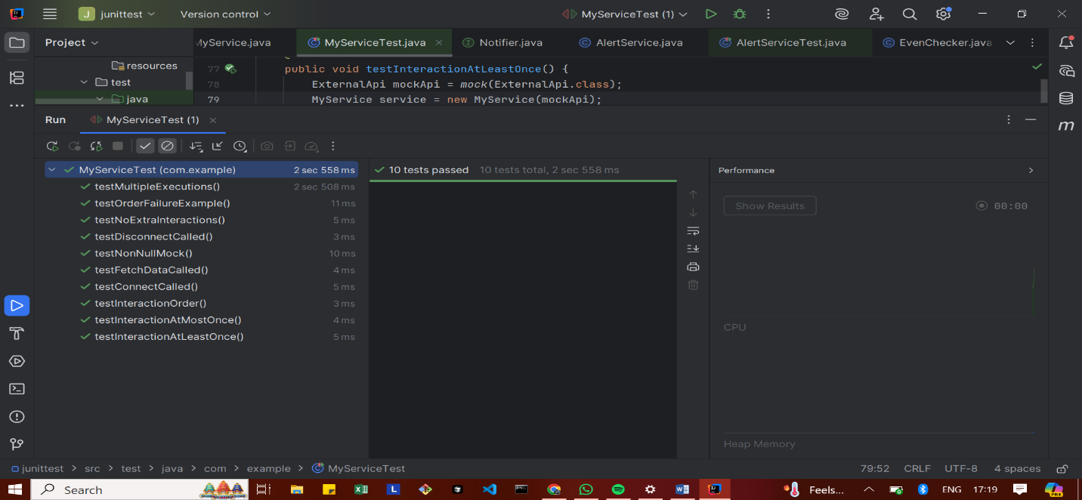

Exercise 7: Handling Void Methods with Exceptions
ExternalApi.java
package com.example;
public interface ExternalApi {
void riskyOperation();
}

MyService.java
package com.example;
public class MyService {
private ExternalApi api;
public MyService(ExternalApi api) {
this.api = api;
}
public void performRiskyAction() {
api.riskyOperation();
}
}

MyServiceTest.java
package com.example;
import org.junit.jupiter.api.Test;
import org.mockito.Mockito;
import static org.junit.jupiter.api.Assertions.assertThrows;
import static org.mockito.Mockito.doThrow;
import static org.mockito.Mockito.verify;
public class MyServiceTest {
@Test
public void testRiskyOperationThrowsException() {
// Step 1: Create mock
ExternalApi mockApi = Mockito.mock(ExternalApi.class);
// Step 2: Stub the void method to throw exception
doThrow(new RuntimeException("Risk failed")).when(mockApi).riskyOperation();
// Step 3: Use the mock in service
MyService service = new MyService(mockApi);
// Assert that exception is thrown
assertThrows(RuntimeException.class, service::performRiskyAction);
// Step 4: Verify the method was called
verify(mockApi).riskyOperation();
}
}

OUTPUT
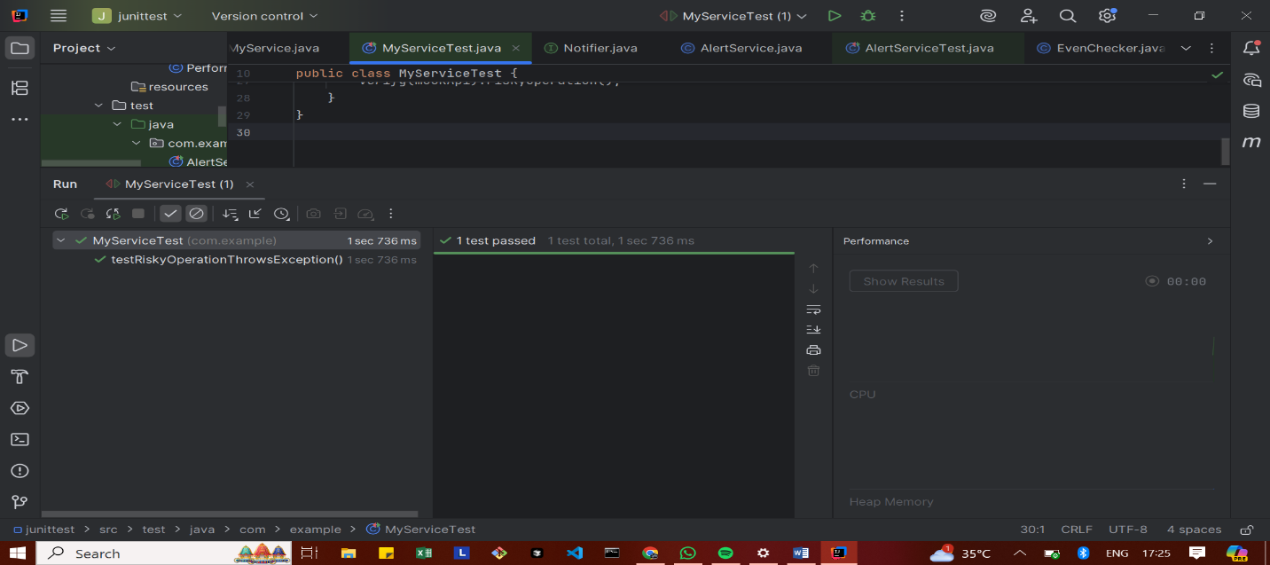

Advanced Mockito Hands-On Exercises

Exercise 1: Mocking Databases and Repositories
Repository.java
package com.example;
public interface Repository {
String getData();
}

Service.java
package com.example;
public class Service {
private final Repository repository;
public Service(Repository repository) {
this.repository = repository;
}
public String processData() {
String data = repository.getData();
return "Processed " + data;
}
}

ServiceTest.java
package com.example;
import static org.mockito.Mockito.*;
import org.junit.jupiter.api.Test;
import static org.junit.jupiter.api.Assertions.*;
public class ServiceTest {
@Test
public void testServiceWithMockRepository() {
Repository mockRepository = mock(Repository.class);
when(mockRepository.getData()).thenReturn("Mock Data");
Service service = new Service(mockRepository);
String result = service.processData();
assertEquals("Processed Mock Data", result);
}
}

OUTPUT
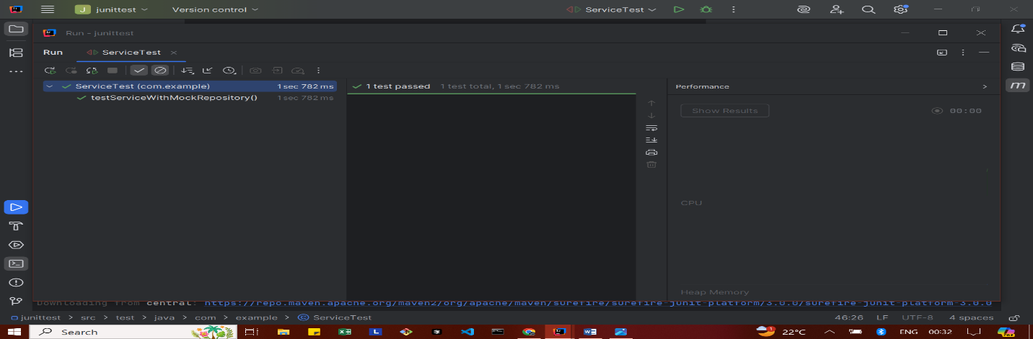

Exercise 2: Mocking External Services (RESTful APIs)
RestClient.java
package com.example;
public interface RestClient {
String getResponse();
}

ApiService.java
package com.example;
public class ApiService {
private final RestClient restClient;
public ApiService(RestClient restClient) {
this.restClient = restClient;
}
public String fetchData() {
String response = restClient.getResponse();
return "Fetched " + response;
}
}

ApiServiceTest.java
package com.example;
import static org.mockito.Mockito.*;
import org.junit.jupiter.api.Test;
import static org.junit.jupiter.api.Assertions.*;
public class ApiServiceTest {
@Test
public void testServiceWithMockRestClient() {
RestClient mockRestClient = mock(RestClient.class);
when(mockRestClient.getResponse()).thenReturn("Mock Response");
ApiService apiService = new ApiService(mockRestClient);
String result = apiService.fetchData();
assertEquals("Fetched Mock Response", result);
}
}

OUTPUT
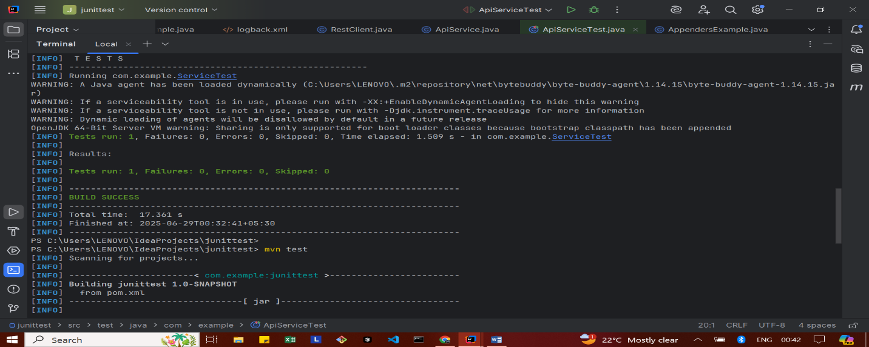
Exercise 3: Mocking File I/O
FileReader.java
package com.example;
public interface FileReader {
String read();
}

FileWriter.java
package com.example;
public interface FileWriter {
void write(String content);
}

FileService.java
package com.example;
public class FileService {
private final FileReader fileReader;
private final FileWriter fileWriter;
public FileService(FileReader fileReader, FileWriter fileWriter) {
this.fileReader = fileReader;
this.fileWriter = fileWriter;
}
public String processFile() {
String content = fileReader.read();
String processed = "Processed " + content;
fileWriter.write(processed);
return processed;
}
}

FileServiceTest.java
package com.example;
import static org.mockito.Mockito.*;
import org.junit.jupiter.api.Test;
import static org.junit.jupiter.api.Assertions.*;
public class FileServiceTest {
@Test
public void testServiceWithMockFileIO() {
FileReader mockFileReader = mock(FileReader.class);
FileWriter mockFileWriter = mock(FileWriter.class);
when(mockFileReader.read()).thenReturn("Mock File Content");
FileService fileService = new FileService(mockFileReader, mockFileWriter);
String result = fileService.processFile();
verify(mockFileWriter).write("Processed Mock File Content");
assertEquals("Processed Mock File Content", result);
}
}

OUTPUT
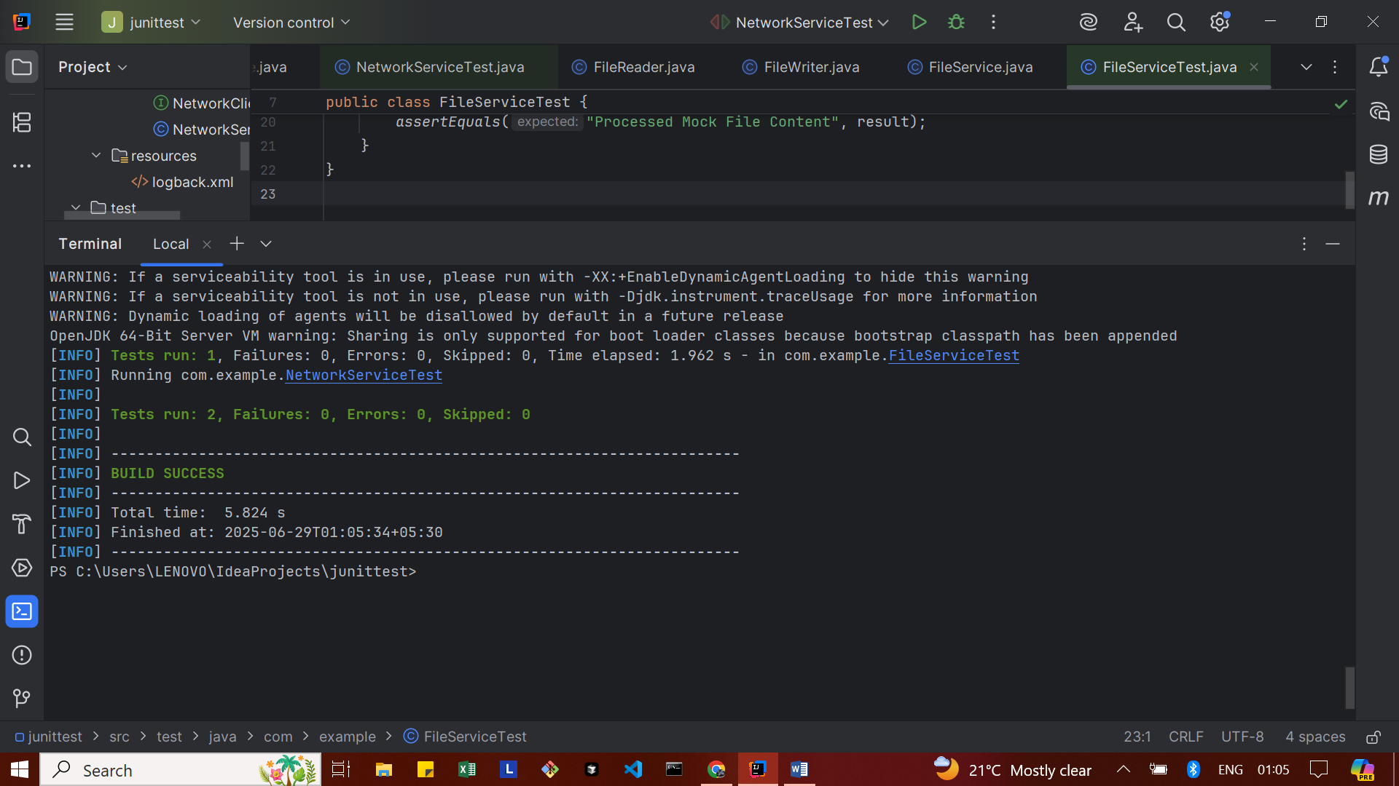
Exercise 4: Mocking Network Interactions

NetworkClient.java
package com.example;
public interface NetworkClient {
String connect();
}

NetworkService.java
package com.example;
public class NetworkService {
private final NetworkClient networkClient;
public NetworkService(NetworkClient networkClient) {
this.networkClient = networkClient;
}
public String connectToServer() {
return "Connected to " + networkClient.connect();
}
}

NetworkServiceTest.java
package com.example;
import static org.mockito.Mockito.*;
import org.junit.jupiter.api.Test;
import static org.junit.jupiter.api.Assertions.*;
public class NetworkServiceTest {
@Test
public void testServiceWithMockNetworkClient() {
NetworkClient mockNetworkClient = mock(NetworkClient.class);
when(mockNetworkClient.connect()).thenReturn("Mock Connection");
NetworkService networkService = new NetworkService(mockNetworkClient);
String result = networkService.connectToServer();
assertEquals("Connected to Mock Connection", result);
}
}

OUTPUT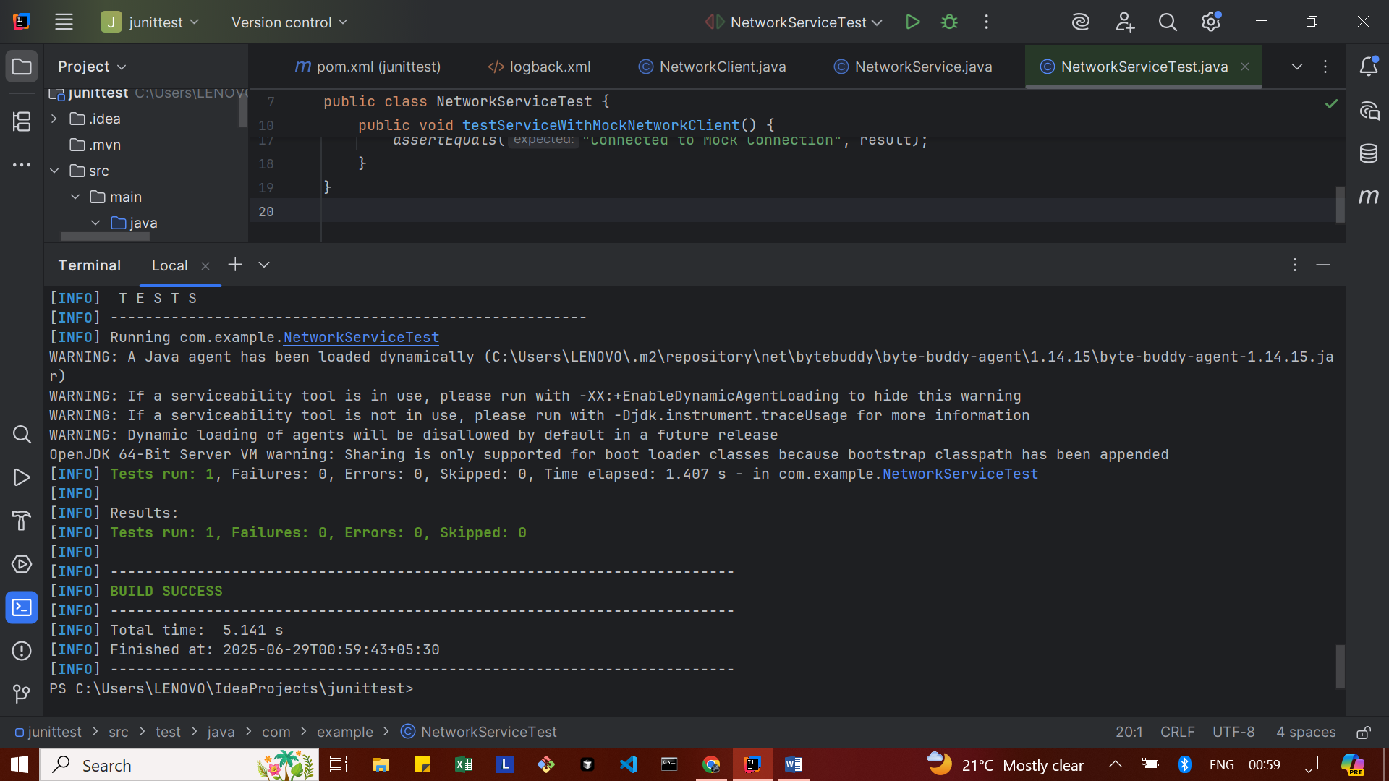
Exercise 5: Mocking Multiple Return Values
Repository.java
package com.example;
public interface Repository {
String getData();
}

Service.java
package com.example;
public class Service {
private final Repository repository;
public Service(Repository repository) {
this.repository = repository;
}
public String processData() {
return "Processed " + repository.getData();
}
}

MultiReturnServiceTest.java
package com.example;
import static org.mockito.Mockito.*;
import org.junit.jupiter.api.Test;
import static org.junit.jupiter.api.Assertions.*;
public class MultiReturnServiceTest {
@Test
public void testServiceWithMultipleReturnValues() {
Repository mockRepository = mock(Repository.class);
when(mockRepository.getData())
.thenReturn("First Mock Data")
.thenReturn("Second Mock Data");
Service service = new Service(mockRepository);
String firstResult = service.processData();
String secondResult = service.processData();
assertEquals("Processed First Mock Data", firstResult);
assertEquals("Processed Second Mock Data", secondResult);
}
}

OUTPUT
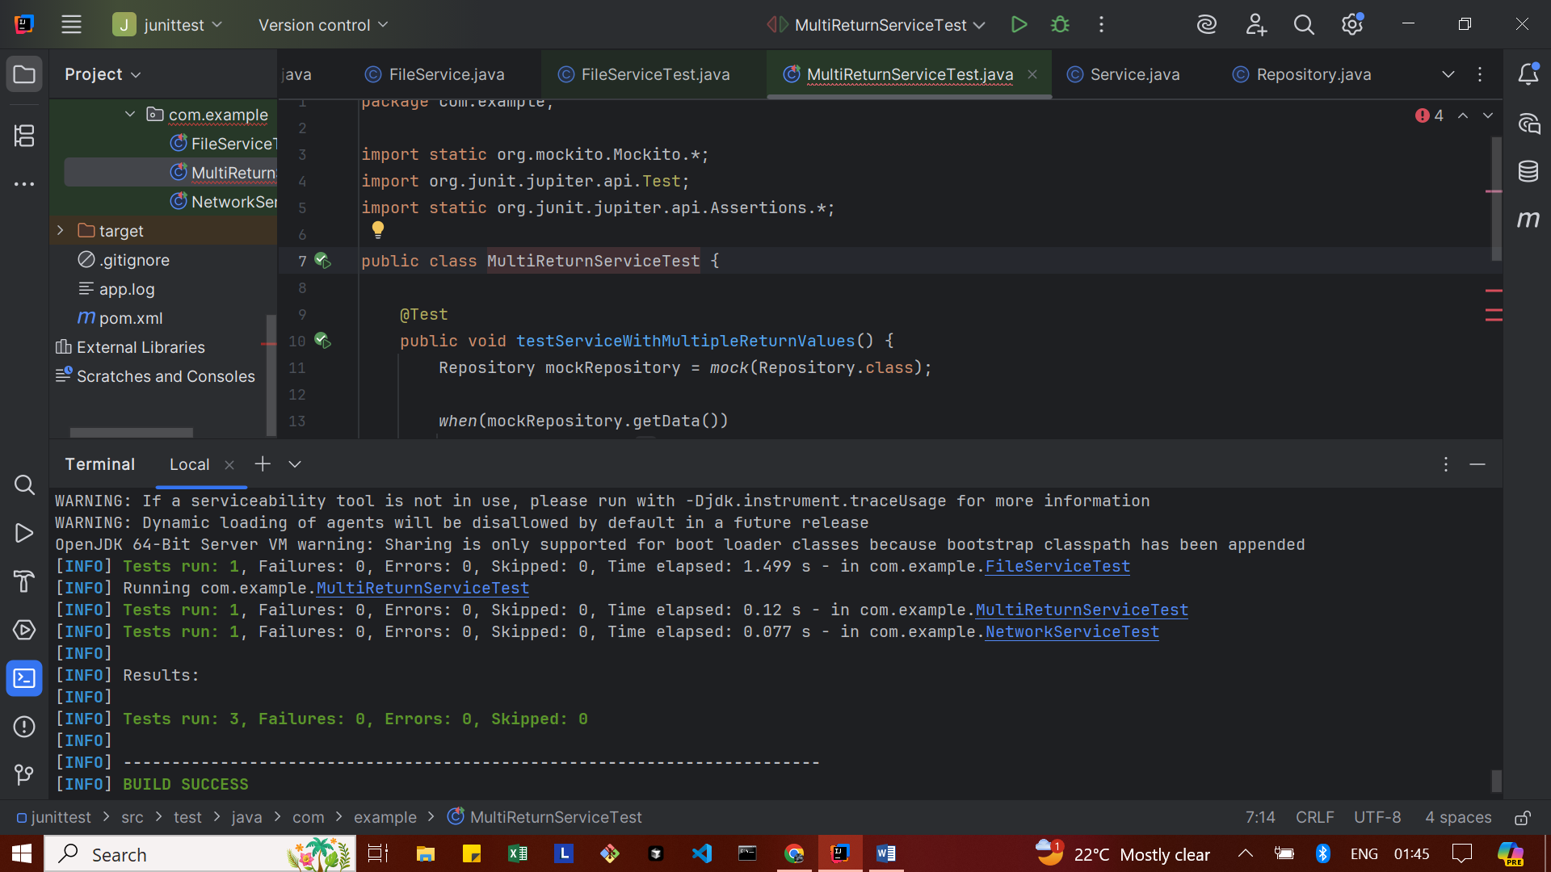

Spring Testing Exercises
Exercise 1: Basic Unit Test for a Service Method
CalculatorService.java
package com.example.SpringTest;
import org.springframework.stereotype.Service;
@Service
public class CalculatorService {
public int add(int a, int b) {
return a + b;
}
}

CalculatorServiceTest.java
package com.example.SpringTest;
import org.junit.jupiter.api.Test;
import static org.junit.jupiter.api.Assertions.*;
class CalculatorServiceTest {
CalculatorService calculatorService = new CalculatorService();
@Test
void testAdd() {
int result = calculatorService.add(5, 3);
assertEquals(8, result, "Addition should return correct sum");
}
}

OUTPUT
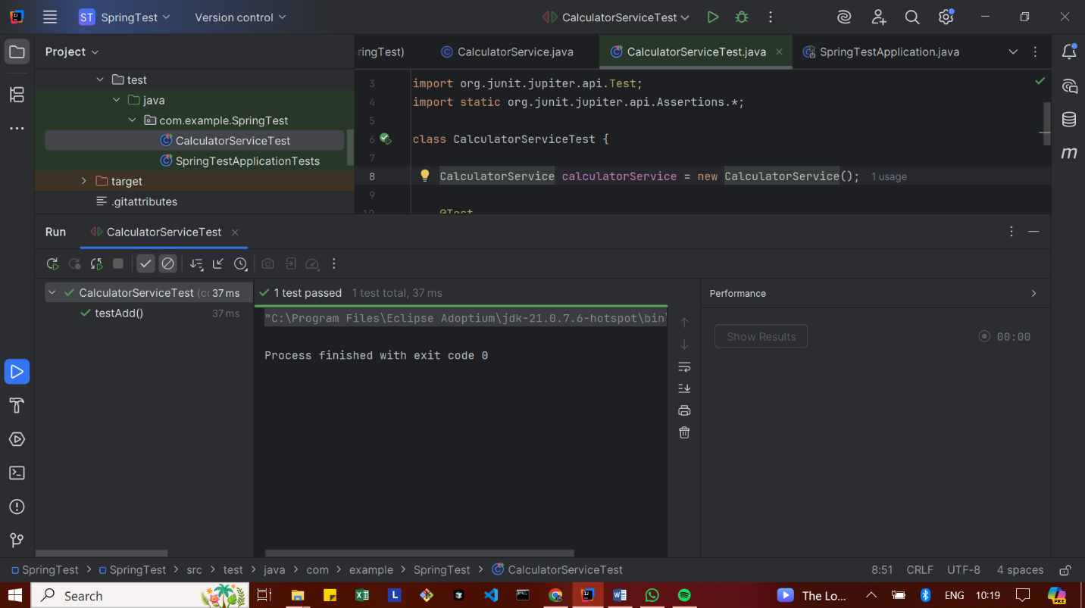

Exercise 2: Mocking a Repository in a Service Test
User.java
package com.example.SpringTest;
import jakarta.persistence.Entity;
import jakarta.persistence.Id;
@Entity
public class User {
@Id
private Long id;
private String name;
// ✅ No-arg constructor (required by JPA)
public User() {}
// ✅ All-args constructor (you need this!)
public User(Long id, String name) {
this.id = id;
this.name = name;
}
// ✅ Getters & Setters
public Long getId() {
return id;
}
public void setId(Long id) {
this.id = id;
}
public String getName() {
return name;
}
public void setName(String name) {
this.name = name;
}
}
UserRepository.java
package com.example.SpringTest;
import org.springframework.data.jpa.repository.JpaRepository;
public interface UserRepository extends JpaRepository<User, Long> {
}

UserService.java
package com.example.SpringTest;
import org.springframework.beans.factory.annotation.Autowired;
import org.springframework.stereotype.Service;
@Service
public class UserService {
@Autowired
private UserRepository userRepository;
public User getUserById(Long id) {
return userRepository.findById(id).orElse(null);
}
}

UserServiceTest.java
package com.example.SpringTest;
import org.junit.jupiter.api.Test;
import org.mockito.InjectMocks;
import org.mockito.Mock;
import org.mockito.MockitoAnnotations;
import static org.mockito.Mockito.*;
import static org.junit.jupiter.api.Assertions.*;
import java.util.Optional;
public class UserServiceTest {
@Mock
private UserRepository userRepository;
@InjectMocks
private UserService userService;
public UserServiceTest() {
MockitoAnnotations.openMocks(this); // initialize mocks
}
@Test
void testGetUserById() {
// Arrange
User mockUser = new User(1L, "Alice");
when(userRepository.findById(1L)).thenReturn(Optional.of(mockUser));
// Act
User result = userService.getUserById(1L);
// Assert
assertNotNull(result);
assertEquals("Alice", result.getName());
verify(userRepository, times(1)).findById(1L);
}
}
OUTPUT
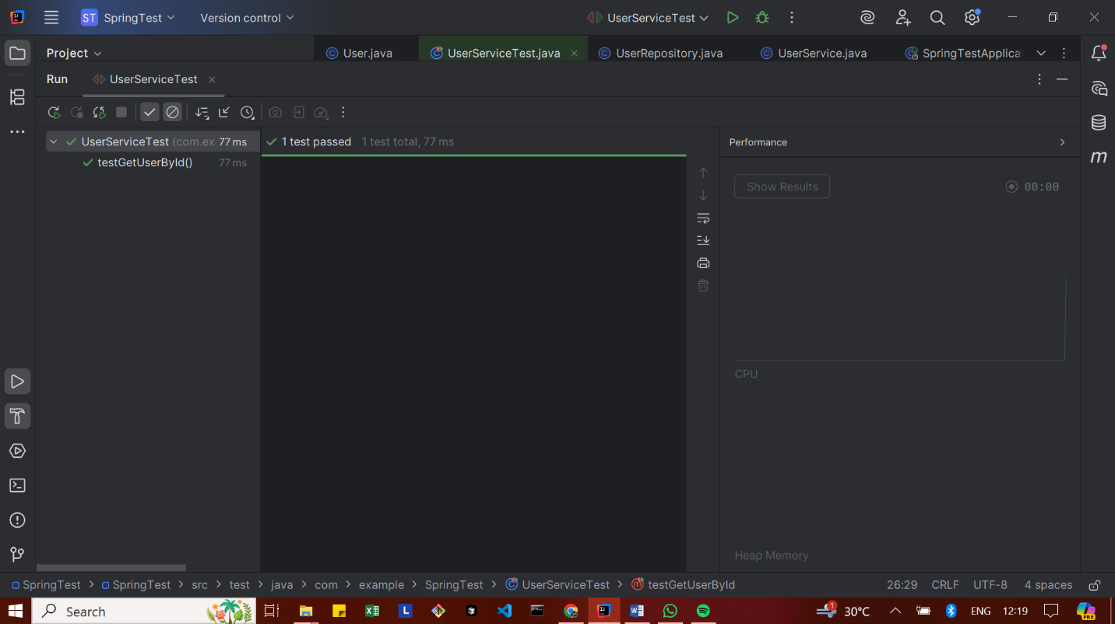
Exercise 3: Testing a REST Controller with MockMvc
UserController.java
package com.example.SpringTest;
import org.springframework.beans.factory.annotation.Autowired;
import org.springframework.http.ResponseEntity;
import org.springframework.web.bind.annotation.*;
@RestController
@RequestMapping("/users")
public class UserController {
@Autowired
private UserService userService;
@GetMapping("/{id}")
public ResponseEntity<User> getUser(@PathVariable Long id) {
return ResponseEntity.ok(userService.getUserById(id));
}
}

UserControllerTest.java
package com.example.SpringTest;
import org.junit.jupiter.api.Test;
import org.mockito.Mockito;
import static org.mockito.Mockito.when;
import org.springframework.beans.factory.annotation.Autowired;
import org.springframework.boot.test.autoconfigure.web.servlet.WebMvcTest;
import org.springframework.boot.test.mock.mockito.MockBean;
import org.springframework.test.web.servlet.MockMvc;
import org.springframework.test.web.servlet.request.MockMvcRequestBuilders;
import static org.springframework.test.web.servlet.result.MockMvcResultMatchers.*;
@WebMvcTest(UserController.class)
public class UserControllerTest {
@Autowired
private MockMvc mockMvc;
@MockBean
private UserService userService;
@Test
void testGetUserById() throws Exception {
User mockUser = new User(1L, "Alice");
when(userService.getUserById(1L)).thenReturn(mockUser);
mockMvc.perform(MockMvcRequestBuilders.get("/users/1"))
.andExpect(status().isOk())
.andExpect(jsonPath("$.id").value(1))
.andExpect(jsonPath("$.name").value("Alice"));
}
}

OUTPUT
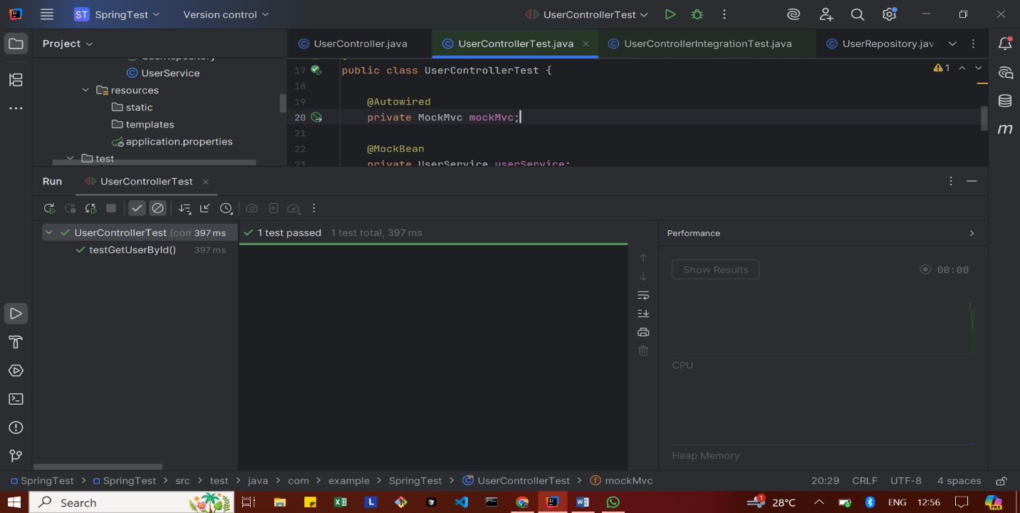
Exercise 4: Integration Test with Spring Boot
application.properties
spring.datasource.url=jdbc:h2:mem:testdb
spring.datasource.driverClassName=org.h2.Driver
spring.datasource.username=sa
spring.datasource.password=
spring.jpa.hibernate.ddl-auto=create
spring.jpa.database-platform=org.hibernate.dialect.H2Dialect

UserControllerIntegrationTest.java
package com.example.SpringTest;
import com.example.SpringTest.User;
import com.example.SpringTest.UserRepository;
import org.junit.jupiter.api.BeforeEach;
import org.junit.jupiter.api.Test;
import org.springframework.beans.factory.annotation.Autowired;
import org.springframework.boot.test.autoconfigure.web.servlet.AutoConfigureMockMvc;
import org.springframework.boot.test.context.SpringBootTest;
import org.springframework.http.MediaType;
import org.springframework.test.web.servlet.MockMvc;
import static org.springframework.test.web.servlet.request.MockMvcRequestBuilders.get;
import static org.springframework.test.web.servlet.result.MockMvcResultMatchers.*;
@SpringBootTest
@AutoConfigureMockMvc
public class UserControllerIntegrationTest {
@Autowired
private MockMvc mockMvc;
@Autowired
private UserRepository userRepository;
@BeforeEach
public void setup() {
userRepository.deleteAll(); // clean before each test
User user = new User();
user.setId(1L);
user.setName("Alice");
userRepository.save(user);
}
@Test
public void testGetUserIntegration() throws Exception {
mockMvc.perform(get("/users/1").contentType(MediaType.APPLICATION_JSON))
.andExpect(status().isOk())
.andExpect(jsonPath("$.id").value(1))
.andExpect(jsonPath("$.name").value("Alice"));
}
}

OUTPUT
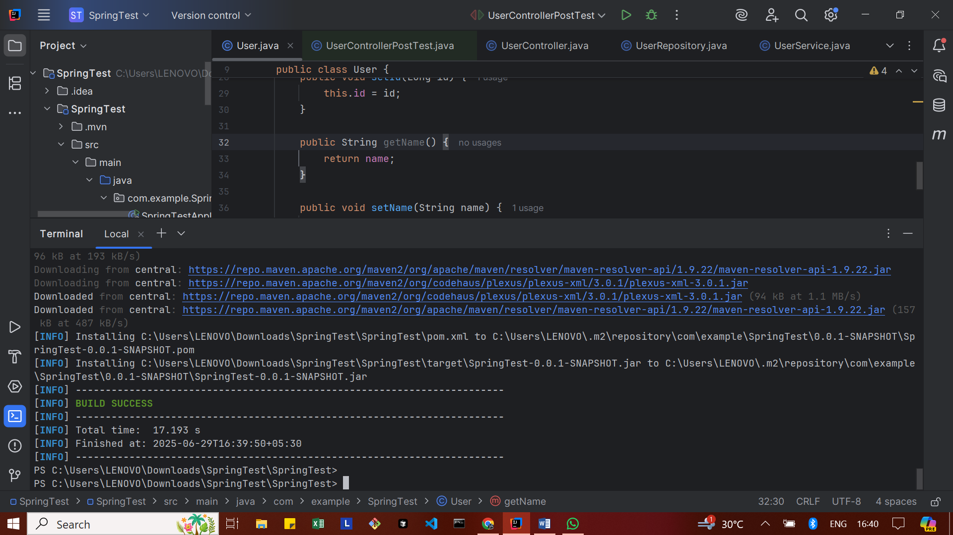

Exercise 5: Test Controller POST Endpoint
User.java
package com.example.SpringTest;
import jakarta.persistence.Entity;
import jakarta.persistence.Id;
import jakarta.persistence.Table;
@Entity
@Table(name = "users") // <-- important fix!
public class User {
@Id
private Long id;
private String name;
// Default constructor is required for JPA
public User() {
}
public User(Long id, String name) {
this.id = id;
this.name = name;
}
// Getters & Setters
public Long getId() {
return id;
}
public void setId(Long id) {
this.id = id;
}
public String getName() {
return name;
}
public void setName(String name) {
this.name = name;
}
}

UserRepository.java
package com.example.SpringTest;
import org.springframework.data.jpa.repository.JpaRepository;
public interface UserRepository extends JpaRepository<User, Long> {
}

UserService.java
package com.example.SpringTest;
import org.springframework.beans.factory.annotation.Autowired;
import org.springframework.stereotype.Service;
@Service
public class UserService {
@Autowired
private UserRepository userRepository;
public User getUserById(Long id) {
return userRepository.findById(id).orElse(null);
}
public User saveUser(User user) {
return userRepository.save(user);
}
}

UserController.java
package com.example.SpringTest;
import org.springframework.beans.factory.annotation.Autowired;
import org.springframework.http.ResponseEntity;
import org.springframework.web.bind.annotation.*;
@RestController
@RequestMapping("/users")
public class UserController {
@Autowired
private UserService userService;
@GetMapping("/{id}")
public ResponseEntity<User> getUser(@PathVariable Long id) {
return ResponseEntity.ok(userService.getUserById(id));
}
@PostMapping
public ResponseEntity<User> createUser(@RequestBody User user) {
return ResponseEntity.ok(userService.saveUser(user));
}
}

UserControllerPostTest.java
package com.example.SpringTest;
import com.fasterxml.jackson.databind.ObjectMapper;
import org.junit.jupiter.api.Test;
import org.springframework.beans.factory.annotation.Autowired;
import org.springframework.boot.test.autoconfigure.web.servlet.AutoConfigureMockMvc;
import org.springframework.boot.test.context.SpringBootTest;
import org.springframework.http.MediaType;
import org.springframework.test.web.servlet.MockMvc;
import static org.springframework.test.web.servlet.request.MockMvcRequestBuilders.post;
import static org.springframework.test.web.servlet.result.MockMvcResultMatchers.*;
@SpringBootTest
@AutoConfigureMockMvc
public class UserControllerPostTest {
@Autowired
private MockMvc mockMvc;
@Autowired
private ObjectMapper objectMapper; // for JSON conversion
@Test
public void testCreateUser() throws Exception {
User user = new User();
user.setId(100L);
user.setName("TestUser");
mockMvc.perform(post("/users")
.contentType(MediaType.APPLICATION_JSON)
.content(objectMapper.writeValueAsString(user)))
.andExpect(status().isOk())
.andExpect(jsonPath("$.id").value(100))
.andExpect(jsonPath("$.name").value("TestUser"));
}
}

OUTPUT


Exercise 6: Test Service Exception Handling
UserService.java
package com.example.SpringTest;
import java.util.Optional;
import org.springframework.stereotype.Service;
@Service
public class UserService {
private final UserRepository userRepository;
public UserService(UserRepository userRepository) {
this.userRepository = userRepository;
}
public User getUserById(Long id) {
return userRepository.findById(id)
.orElseThrow(() -> new RuntimeException("User not found"));
}
public User saveUser(User user) {
return userRepository.save(user);
}
}

UserServiceExceptionTest.java
package com.example.SpringTest;
import static org.junit.jupiter.api.Assertions.assertThrows;
import java.util.Optional;
import org.junit.jupiter.api.BeforeEach;
import org.junit.jupiter.api.Test;
import org.mockito.Mockito;
public class UserServiceExceptionTest {
private UserRepository userRepository;
private UserService userService;
@BeforeEach
public void setup() {
userRepository = Mockito.mock(UserRepository.class);
userService = new UserService(userRepository);
}
@Test
public void testGetUserById_UserNotFound_ShouldThrowException() {
// Arrange
Long userId = 100L;
Mockito.when(userRepository.findById(userId)).thenReturn(Optional.empty());
// Act & Assert
assertThrows(RuntimeException.class, () -> {
userService.getUserById(userId);
});
}
}

OUTPUT
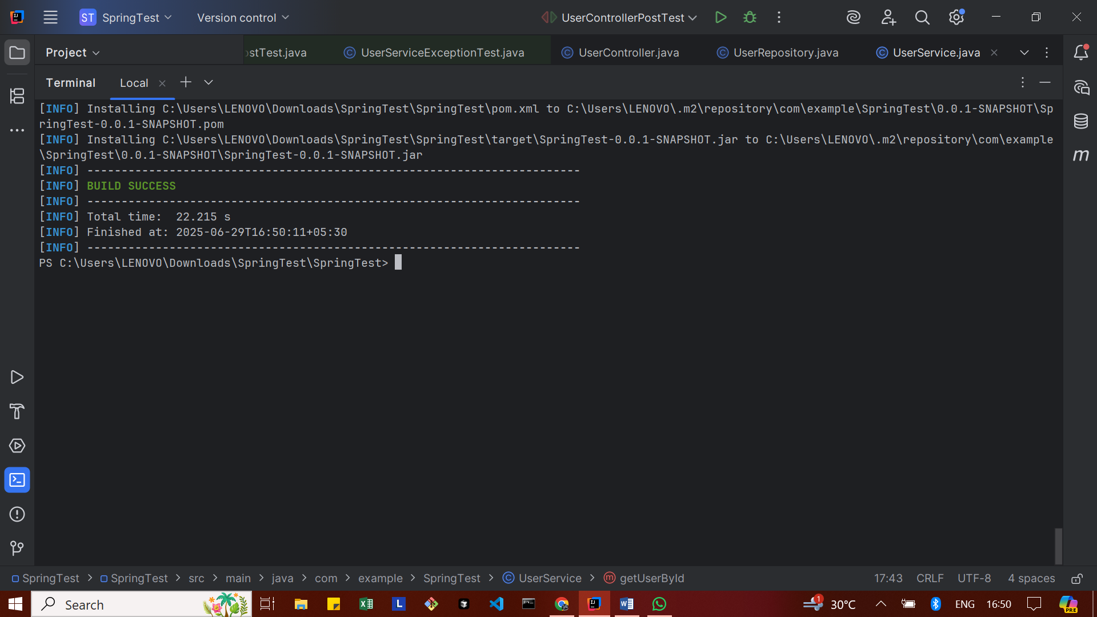

Exercise 7: Test Custom Repository Query

User.java
package com.example.SpringTest;
import jakarta.persistence.Entity;
import jakarta.persistence.Id;
import jakarta.persistence.Table;
@Entity
@Table(name = "\"user\"") // Escaping reserved SQL keyword using double quotes
public class User {
@Id
private Long id;
private String name;
public User() {
}
public User(Long id, String name) {
this.id = id;
this.name = name;
}
// Getter
public Long getId() {
return id;
}
public String getName() {
return name;
}
// Setter
public void setId(Long id) {
this.id = id;
}
public void setName(String name) {
this.name = name;
}
}

UserRepository.java
package com.example.SpringTest;
import java.util.List;
import org.springframework.data.jpa.repository.JpaRepository;
public interface UserRepository extends JpaRepository<User, Long> {
List<User> findByName(String name);
}

UserRepositoryQueryTest.java
package com.example.SpringTest;
import static org.assertj.core.api.Assertions.assertThat;
import java.util.List;
import org.junit.jupiter.api.BeforeEach;
import org.junit.jupiter.api.Test;
import org.springframework.beans.factory.annotation.Autowired;
import org.springframework.boot.test.autoconfigure.orm.jpa.DataJpaTest;
@DataJpaTest
public class UserRepositoryQueryTest {
@Autowired
private UserRepository userRepository;
@BeforeEach
public void setup() {
userRepository.deleteAll(); // Clean before inserting
userRepository.save(new User(1L, "Santhiya"));
userRepository.save(new User(2L, "Arun"));
userRepository.save(new User(3L, "Santhiya")); // duplicate name
}
@Test
public void testFindByName_ReturnsCorrectUsers() {
List<User> users = userRepository.findByName("Santhiya");
assertThat(users).hasSize(2);
assertThat(users.get(0).getName()).isEqualTo("Santhiya");
assertThat(users.get(1).getName()).isEqualTo("Santhiya");
}
}

OUTPUT
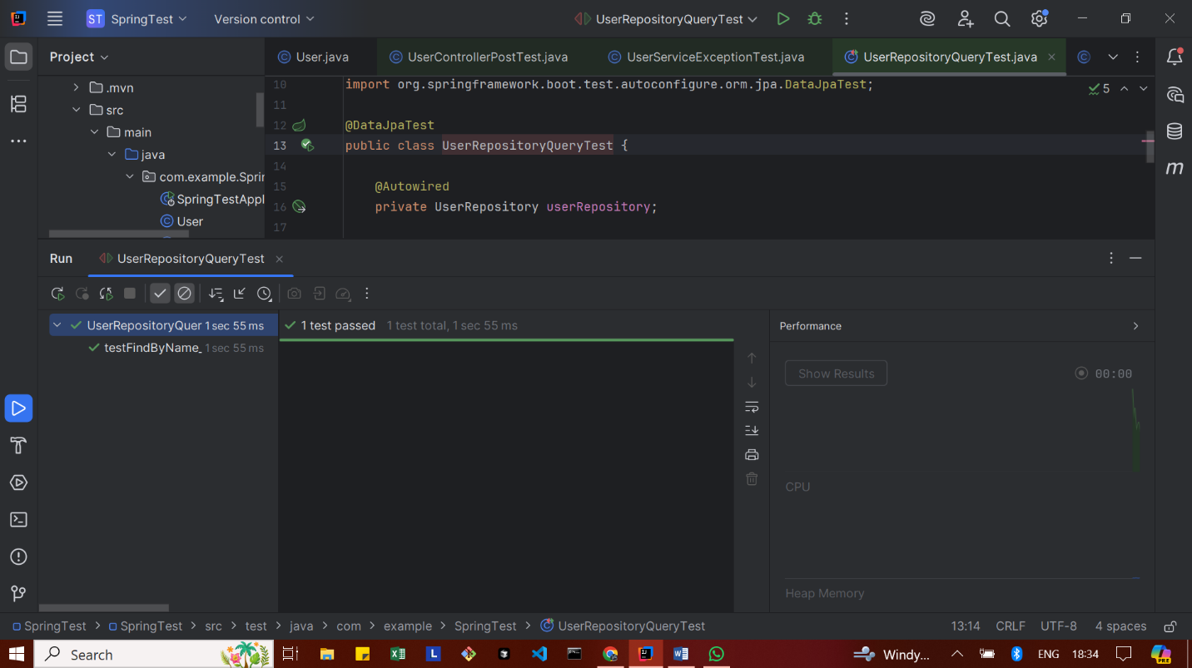
Exercise 8: Test Controller Exception Handling
GlobalExceptionHandler.java
package com.example.SpringTest;
import org.springframework.http.HttpStatus;
import org.springframework.http.ResponseEntity;
import org.springframework.web.bind.annotation.ControllerAdvice;
import org.springframework.web.bind.annotation.ExceptionHandler;
import java.util.NoSuchElementException;
@ControllerAdvice
public class GlobalExceptionHandler {
@ExceptionHandler(NoSuchElementException.class)
public ResponseEntity<String> handleNotFound(NoSuchElementException ex) {
return ResponseEntity.status(HttpStatus.NOT_FOUND).body("User not found");
}
}

UserController.java
package com.example.SpringTest;
import java.util.NoSuchElementException; // ✅ ADD THIS LINE
import org.springframework.beans.factory.annotation.Autowired;
import org.springframework.http.ResponseEntity;
import org.springframework.web.bind.annotation.*;
@RestController
@RequestMapping("/users")
public class UserController {
@Autowired
private UserService userService;
@GetMapping("/{id}")
public ResponseEntity<User> getUserById(@PathVariable Long id) {
User user = userService.getUserById(id)
.orElseThrow(NoSuchElementException::new);
return ResponseEntity.ok(user);
}
@PostMapping
public ResponseEntity<User> createUser(@RequestBody User user) {
return ResponseEntity.ok(userService.saveUser(user));
}
}

UserControllerExceptionTest.java
package com.example.SpringTest;
import org.junit.jupiter.api.Test;
import org.springframework.beans.factory.annotation.Autowired;
import org.springframework.boot.test.autoconfigure.web.servlet.WebMvcTest;
import org.springframework.boot.test.mock.mockito.MockBean;
import org.springframework.http.MediaType;
import org.springframework.test.web.servlet.MockMvc;
import java.util.Optional;
import static org.mockito.Mockito.when;
import static org.springframework.test.web.servlet.request.MockMvcRequestBuilders.get;
import static org.springframework.test.web.servlet.result.MockMvcResultMatchers.*;
@WebMvcTest(UserController.class)
public class UserControllerExceptionTest {
@Autowired
private MockMvc mockMvc;
@MockBean
private UserService userService;
@Test
public void testGetUser_NotFound_ShouldReturn404() throws Exception {
Long userId = 100L;
when(userService.getUserById(userId)).thenReturn(Optional.empty());
mockMvc.perform(get("/users/{id}", userId)
.accept(MediaType.APPLICATION_JSON))
.andExpect(status().isNotFound())
.andExpect(content().string("User not found"));
}
}

OUTPUT
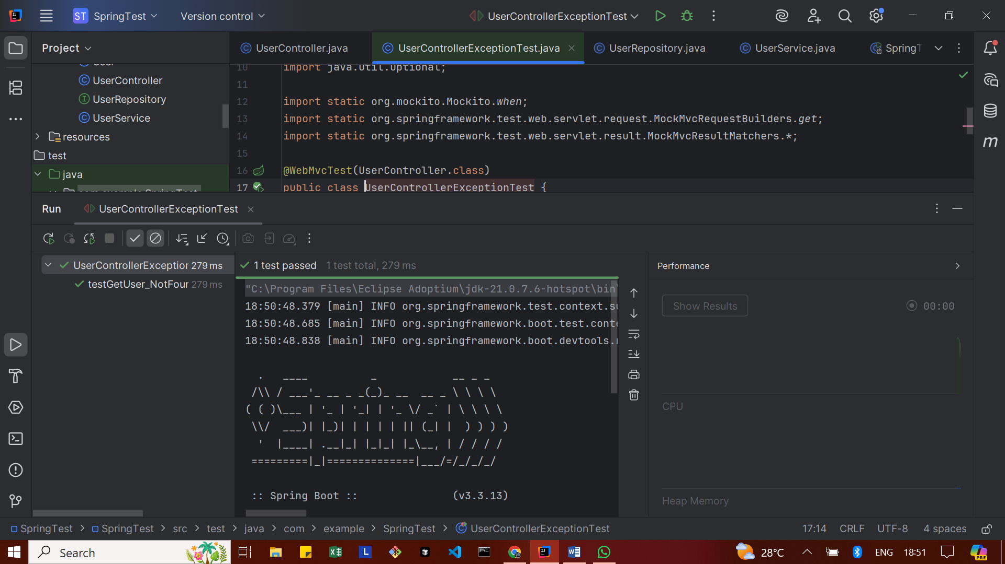
Exercise 9: Parameterized Test with Junit
UserService.java
package com.example.SpringTest;
import java.util.Optional;
import org.springframework.stereotype.Service;
@Service
public class UserService {
private final UserRepository userRepository;
public UserService(UserRepository userRepository) {
this.userRepository = userRepository;
}
public boolean isValidName(String name) {
return name != null && !name.trim().isEmpty();
}
public Optional<User> getUserById(Long id) {
return userRepository.findById(id);
}
public User saveUser(User user) {
return userRepository.save(user);
}
}

UserServiceParameterizedTest.java
package com.example.SpringTest;
import org.junit.jupiter.params.ParameterizedTest;
import org.junit.jupiter.params.provider.ValueSource;
import org.junit.jupiter.api.Assertions;
public class UserServiceParameterizedTest {
private final UserService userService = new UserService(null); // We don’t need the repository for this test
@ParameterizedTest
@ValueSource(strings = {"Alice", "Bob", "Charlie"})
void testValidUserNames(String name) {
boolean isValid = userService.isValidName(name);
Assertions.assertTrue(isValid, "Expected name to be valid: " + name);
}
@ParameterizedTest
@ValueSource(strings = {"", " ", "\n", "\t"})
void testInvalidUserNames(String name) {
boolean isValid = userService.isValidName(name);
Assertions.assertFalse(isValid, "Expected name to be invalid: " + name);
}
}

OUTPUT
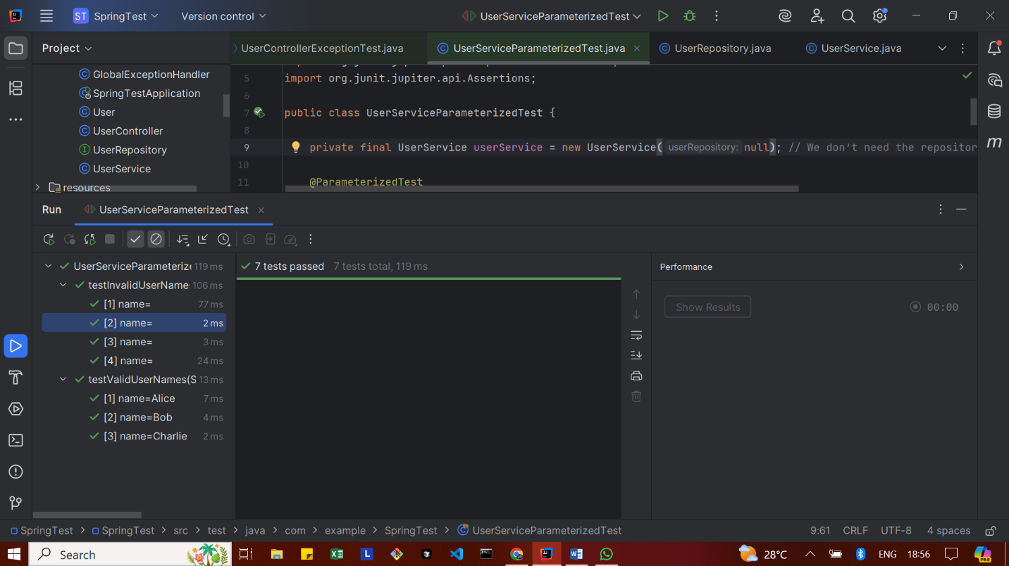
Mocking Dependencies in Spring Tests using Mockito
Exercise 1: Mocking a Service Dependency in a Controller Test
User.java
package com.example.SpringTest;
import jakarta.persistence.Entity;
import jakarta.persistence.Id;
import jakarta.persistence.Table;
@Entity
@Table(name = "users") // Avoid using "user" since it's a reserved word in many databases
public class User {
@Id
private Long id;
private String name;
// ✅ No-arg constructor (required by JPA)
public User() {
}
// ✅ All-args constructor (for test cases and initialization)
public User(Long id, String name) {
this.id = id;
this.name = name;
}
// ✅ Getters and setters
public Long getId() {
return id;
}
public void setId(Long id) {
this.id = id;
}
public String getName() {
return name;
}
public void setName(String name) {
this.name = name;
}
}

UserService.java
package com.example.SpringTest;
import org.springframework.stereotype.Service;
@Service
public class UserService {
private final UserRepository userRepository;
// ✅ Add this constructor
public UserService(UserRepository userRepository) {
this.userRepository = userRepository;
}
// Example method (needed for parameterized test)
public boolean isValidName(String name) {
return name != null && !name.trim().isEmpty();
}
public User getUserById(Long id) {
return userRepository.findById(id).orElse(null);
}
public User saveUser(User user) {
return userRepository.save(user);
}
}

UserController.java
package com.example.SpringTest;
import org.springframework.beans.factory.annotation.Autowired;
import org.springframework.http.ResponseEntity;
import org.springframework.web.bind.annotation.*;
@RestController
@RequestMapping("/users")
public class UserController {
@Autowired
public UserService userService;
@GetMapping("/{id}")
public ResponseEntity<User> getUser(@PathVariable Long id) {
return ResponseEntity.ok(userService.getUserById(id));
}
}

UserControllerTest.java
package com.example.SpringTest;
import static org.mockito.Mockito.*;
import static org.springframework.test.web.servlet.result.MockMvcResultMatchers.*;
import com.fasterxml.jackson.databind.ObjectMapper;
import org.junit.jupiter.api.BeforeEach;
import org.junit.jupiter.api.Test;
import org.springframework.http.MediaType;
import org.springframework.test.web.servlet.MockMvc;
import org.springframework.test.web.servlet.setup.MockMvcBuilders;
import org.springframework.test.web.servlet.request.MockMvcRequestBuilders;
public class UserControllerTest {
private MockMvc mockMvc;
private UserService userService;
private ObjectMapper objectMapper;
@BeforeEach
public void setup() {
userService = mock(UserService.class);
UserController userController = new UserController();
// Inject mock manually since no Spring context
userController.userService = userService;
mockMvc = MockMvcBuilders.standaloneSetup(userController).build();
objectMapper = new ObjectMapper();
}
@Test
public void testGetUserById_ReturnsUser() throws Exception {
// Arrange
Long userId = 1L;
User user = new User();
user.setId(userId);
user.setName("Alice");
when(userService.getUserById(userId)).thenReturn(user);
// Act & Assert
mockMvc.perform(MockMvcRequestBuilders.get("/users/{id}", userId))
.andExpect(status().isOk())
.andExpect(jsonPath("$.id").value(userId))
.andExpect(jsonPath("$.name").value("Alice"));
}
}
OUTPUT
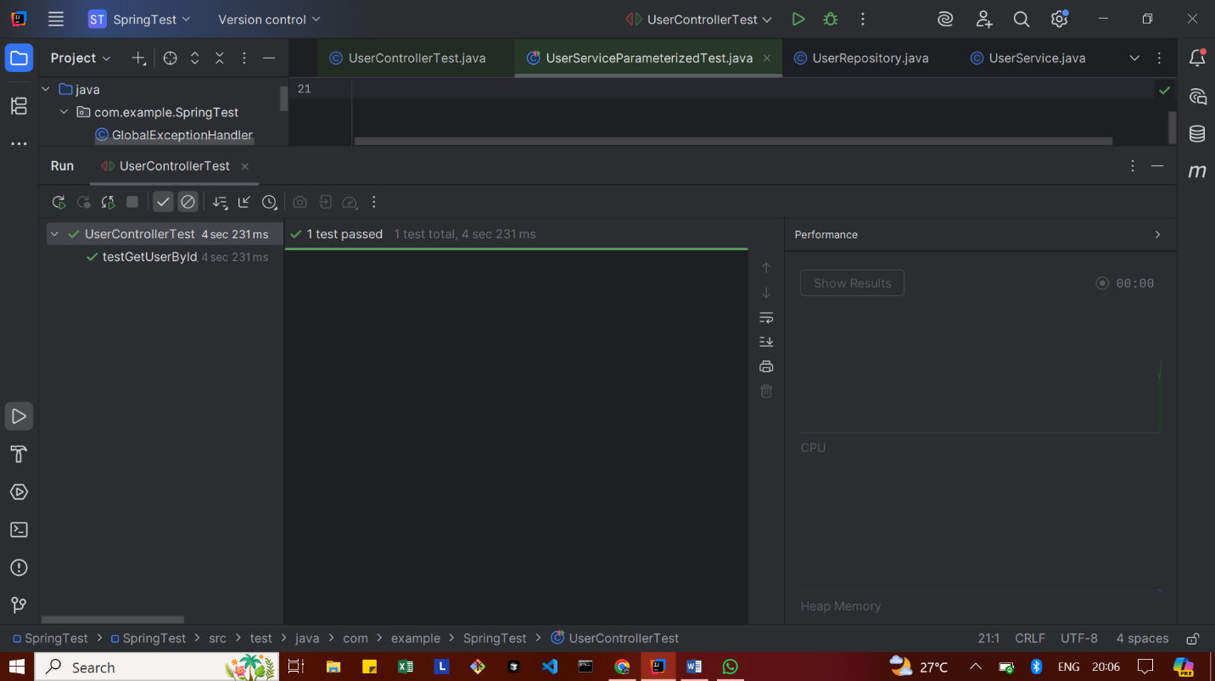

Exercise 2: Mocking a Repository in a Service Test
User.java
package com.example.SpringTest;
import jakarta.persistence.Entity;
import jakarta.persistence.Id;
import jakarta.persistence.Table;
@Entity
@Table(name = "users") // Avoid using "user" since it's a reserved word in many databases
public class User {
@Id
private Long id;
private String name;
// ✅ No-arg constructor (required by JPA)
public User() {
}
// ✅ All-args constructor (for test cases and initialization)
public User(Long id, String name) {
this.id = id;
this.name = name;
}
// ✅ Getters and setters
public Long getId() {
return id;
}
public void setId(Long id) {
this.id = id;
}
public String getName() {
return name;
}
public void setName(String name) {
this.name = name;
}
}

UserRepository.java
package com.example.SpringTest;
import java.util.List;
import org.springframework.data.jpa.repository.JpaRepository;
public interface UserRepository extends JpaRepository<User, Long> {
// ✅ Custom query method declaration
List<User> findByName(String name);
}

UserService.java
package com.example.SpringTest;
import org.springframework.stereotype.Service;
@Service
public class UserService {
private final UserRepository userRepository;
// ✅ Add this constructor
public UserService(UserRepository userRepository) {
this.userRepository = userRepository;
}
// Example method (needed for parameterized test)
public boolean isValidName(String name) {
return name != null && !name.trim().isEmpty();
}
public User getUserById(Long id) {
return userRepository.findById(id).orElse(null);
}
public User saveUser(User user) {
return userRepository.save(user);
}
}

UserServiceTest.java
package com.example.SpringTest;
import static org.junit.jupiter.api.Assertions.*;
import static org.mockito.Mockito.*;
import java.util.Optional;
import org.junit.jupiter.api.BeforeEach;
import org.junit.jupiter.api.Test;
import org.mockito.Mock;
import org.mockito.InjectMocks;
import org.mockito.MockitoAnnotations;
public class UserServiceTest {
@Mock
private UserRepository userRepository;
@InjectMocks
private UserService userService;
@BeforeEach
public void setUp() {
MockitoAnnotations.openMocks(this); // Initializes @Mock and @InjectMocks
}
@Test
public void testGetUserById_WhenUserExists() {
// Arrange
Long userId = 1L;
User mockUser = new User(userId, "Alice");
when(userRepository.findById(userId)).thenReturn(Optional.of(mockUser));
// Act
User result = userService.getUserById(userId);
// Assert
assertNotNull(result);
assertEquals("Alice", result.getName());
assertEquals(userId, result.getId());
}
@Test
public void testGetUserById_WhenUserDoesNotExist() {
// Arrange
Long userId = 2L;
when(userRepository.findById(userId)).thenReturn(Optional.empty());
// Act
User result = userService.getUserById(userId);
// Assert
assertNull(result);
}
@Test
public void testSaveUser_ReturnsSavedUser() {
// Arrange
User userToSave = new User(3L, "Bob");
when(userRepository.save(userToSave)).thenReturn(userToSave);
// Act
User savedUser = userService.saveUser(userToSave);
// Assert
assertNotNull(savedUser);
assertEquals("Bob", savedUser.getName());
verify(userRepository, times(1)).save(userToSave);
}
@Test
public void testIsValidName_WithValidName() {
assertTrue(userService.isValidName("Alice"));
}
@Test
public void testIsValidName_WithEmptyName() {
assertFalse(userService.isValidName(" "));
}
@Test
public void testIsValidName_WithNullName() {
assertFalse(userService.isValidName(null));
}
}

OUTPUT
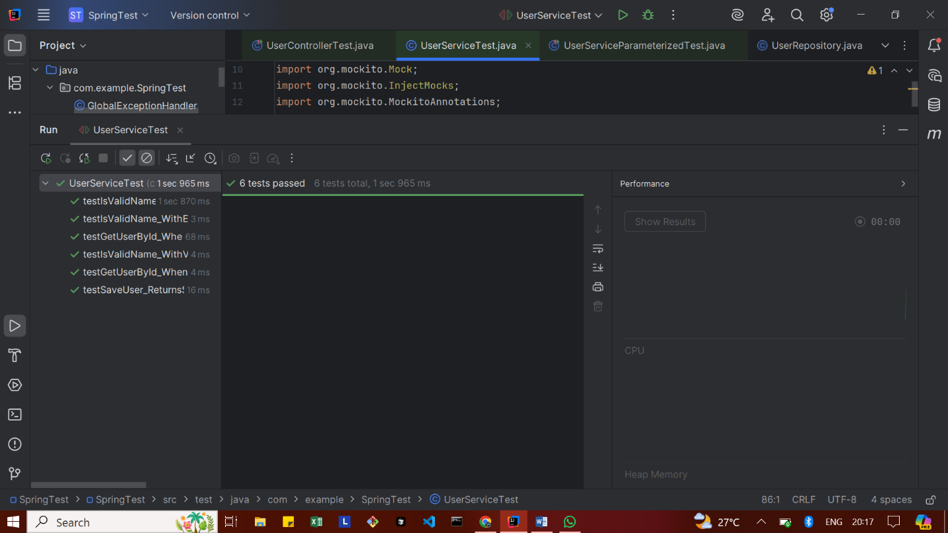
Exercise 3: Mocking a Service Dependency in an Integration Test
User.java
package com.example.SpringTest;
import jakarta.persistence.Entity;
import jakarta.persistence.Id;
import jakarta.persistence.Table;
@Entity
@Table(name = "users") // "user" is a reserved keyword in some databases
public class User {
@Id
private Long id;
private String name;
public User() {}
public User(Long id, String name) {
this.id = id;
this.name = name;
}
public Long getId() {
return id;
}
public void setId(Long id) {
this.id = id;
}
public String getName() {
return name;
}
public void setName(String name) {
this.name = name;
}
}

UserService.java
package com.example.SpringTest;
import org.springframework.stereotype.Service;
import java.util.List;
@Service
public class UserService {
private final UserRepository userRepository;
public UserService(UserRepository userRepository) {
this.userRepository = userRepository;
}
public User getUserById(Long id) {
return userRepository.findById(id).orElse(null);
}
public List<User> getUsersByName(String name) {
return userRepository.findByName(name);
}
public User saveUser(User user) {
return userRepository.save(user);
}
public boolean isValidName(String name) {
return name != null && !name.trim().isEmpty();
}
}
UserController.java
package com.example.SpringTest;
import org.springframework.beans.factory.annotation.Autowired;
import org.springframework.http.ResponseEntity;
import org.springframework.web.bind.annotation.*;
import java.util.List;
@RestController
@RequestMapping("/users")
public class UserController {
@Autowired
public UserService userService;
@GetMapping("/{id}")
public ResponseEntity<User> getUser(@PathVariable Long id) {
return ResponseEntity.ok(userService.getUserById(id));
}
@GetMapping("/search")
public ResponseEntity<List<User>> getUsersByName(@RequestParam String name) {
return ResponseEntity.ok(userService.getUsersByName(name));
}
@PostMapping
public ResponseEntity<User> createUser(@RequestBody User user) {
return ResponseEntity.ok(userService.saveUser(user));
}
}

UserIntegrationTest.java
package com.example.SpringTest;
import static org.mockito.Mockito.when;
import static org.mockito.ArgumentMatchers.any;
import static org.springframework.test.web.servlet.result.MockMvcResultMatchers.*;
import com.fasterxml.jackson.databind.ObjectMapper;
import org.junit.jupiter.api.Test;
import org.springframework.beans.factory.annotation.Autowired;
import org.springframework.boot.test.context.SpringBootTest;
import org.springframework.boot.test.mock.mockito.MockBean;
import org.springframework.boot.test.autoconfigure.web.servlet.AutoConfigureMockMvc;
import org.springframework.http.MediaType;
import org.springframework.test.web.servlet.MockMvc;
import org.springframework.test.web.servlet.request.MockMvcRequestBuilders;
import java.util.List;
@SpringBootTest
@AutoConfigureMockMvc
public class UserIntegrationTest {
@Autowired
private MockMvc mockMvc;
@MockBean
private UserService userService;
private final ObjectMapper objectMapper = new ObjectMapper();
@Test
public void testGetUserById_ReturnsUser() throws Exception {
Long userId = 1L;
User mockUser = new User(userId, "Alice");
when(userService.getUserById(userId)).thenReturn(mockUser);
mockMvc.perform(MockMvcRequestBuilders.get("/users/{id}", userId)
.accept(MediaType.APPLICATION_JSON))
.andExpect(status().isOk())
.andExpect(jsonPath("$.id").value(userId))
.andExpect(jsonPath("$.name").value("Alice"));
}
@Test
public void testSearchUserByName_ReturnsList() throws Exception {
String name = "Alice";
List<User> userList = List.of(new User(1L, "Alice"));
when(userService.getUsersByName(name)).thenReturn(userList);
mockMvc.perform(MockMvcRequestBuilders.get("/users/search")
.param("name", name)
.accept(MediaType.APPLICATION_JSON))
.andExpect(status().isOk())
.andExpect(jsonPath("$[0].name").value("Alice"));
}
@Test
public void testCreateUser_ReturnsSavedUser() throws Exception {
// input (POSTed) user usually has no id
User inputUser = new User(null, "Bob");
// returned (saved) user from service
User savedUser = new User(2L, "Bob");
when(userService.saveUser(any(User.class))).thenReturn(savedUser);
mockMvc.perform(MockMvcRequestBuilders.post("/users")
.contentType(MediaType.APPLICATION_JSON)
.content(objectMapper.writeValueAsString(inputUser)))
.andExpect(status().isOk())
.andExpect(jsonPath("$.id").value(2L))
.andExpect(jsonPath("$.name").value("Bob"));
}
}
OUTPUT
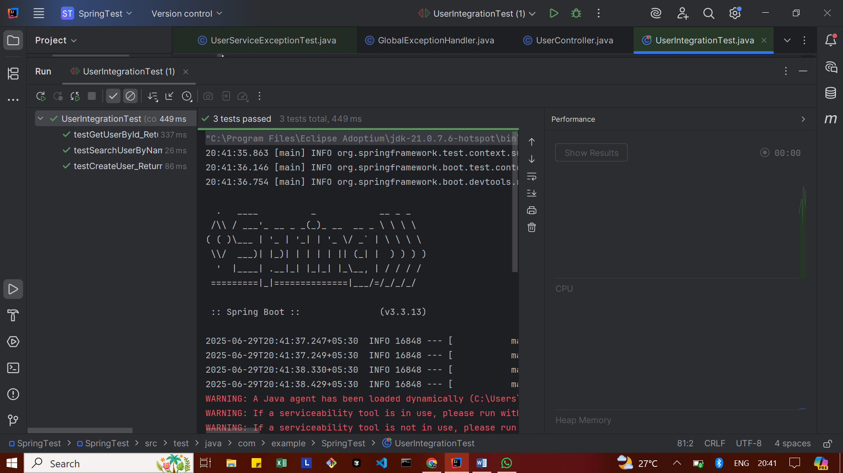

Logging using SLF4J
Exercise 1: Logging Error Messages and Warning Levels
pom.xml
<dependency>
<groupId>org.slf4j</groupId>
<artifactId>slf4j-api</artifactId>
<version>1.7.30</version>
</dependency>
<!-- Logback (SLF4J's logging implementation) -->
<dependency>
<groupId>ch.qos.logback</groupId>
<artifactId>logback-classic</artifactId>
<version>1.5.13</version>
</dependency>

LoggingExample.java
package com.example;
import org.slf4j.Logger;
import org.slf4j.LoggerFactory;
public class LoggingExample {
private static final Logger logger = LoggerFactory.getLogger(LoggingExample.class);
public static void main(String[] args) {
logger.error("This is an error message");
logger.warn("This is a warning message");
}
}

OUTPUT
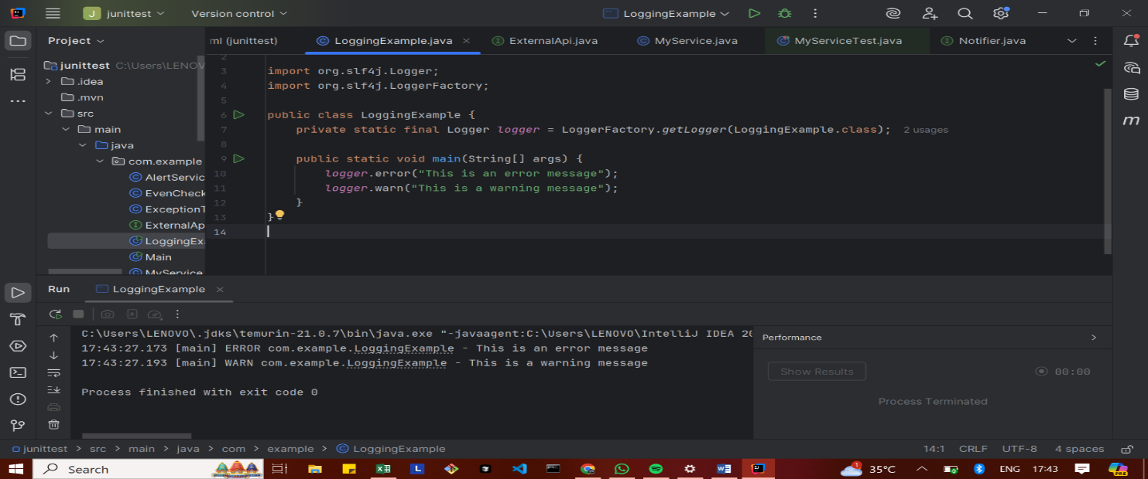
Exercise 2: Parameterized Logging
Pom.xml
<dependencies>

<dependency>
<groupId>org.slf4j</groupId>
<artifactId>slf4j-api</artifactId>
<version>1.7.30</version>
</dependency>
<dependency>
<groupId>ch.qos.logback</groupId>
<artifactId>logback-classic</artifactId>
<version>1.2.3</version>
</dependency>
</dependencies>

ParameterizedLoggingExample.java
package com.example;
import org.slf4j.Logger;
import org.slf4j.LoggerFactory;
public class ParameterizedLoggingExample {
private static final Logger logger = LoggerFactory.getLogger(ParameterizedLoggingExample.class);
public static void main(String[] args) {
String username = "Santhiya";
int attempts = 3;
logger.info("User {} has logged in successfully.", username);
logger.warn("User {} has {} failed login attempts.", username, attempts);
logger.error("User {} triggered a security alert after {} attempts!", username, attempts);
}
}

OUTPUT
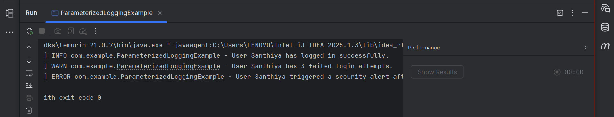

Exercise 3: Using Different Appenders
Pom.xml
<dependencies>

<dependency>
<groupId>org.slf4j</groupId>
<artifactId>slf4j-api</artifactId>
<version>1.7.30</version>
</dependency>
<dependency>
<groupId>ch.qos.logback</groupId>
<artifactId>logback-classic</artifactId>
<version>1.2.3</version>
</dependency>
</dependencies>

Logback.xml
<configuration>
<appender name="console" class="ch.qos.logback.core.ConsoleAppender">
<encoder>
<pattern>%d{HH:mm:ss.SSS} [%thread] %-5level %logger{36} - %msg%n</pattern>
</encoder>
</appender>
<appender name="file" class="ch.qos.logback.core.FileAppender">
<file>app.log</file>
<encoder>
<pattern>%d{HH:mm:ss.SSS} [%thread] %-5level %logger{36} - %msg%n</pattern>
</encoder>
</appender>
<root level="debug">
<appender-ref ref="console" />
<appender-ref ref="file" />
</root>
</configuration>
AppendersExample.java
package com.example;
import org.slf4j.Logger;
import org.slf4j.LoggerFactory;
public class AppendersExample {
private static final Logger logger = LoggerFactory.getLogger(AppendersExample.class);
public static void main(String[] args) {
logger.debug("Debug log - useful for developers");
logger.info("Info log - application started");
logger.warn("Warning log - something might be wrong");
logger.error("Error log - something went wrong!");
}
}

OUTPUT
